MMA series Manual

Marks：Standard by ARC-400

TABLE OF CONTENTS

1：MACHINE STRUCTURE-------------------------------------------------3
2：CIRCUIT DIAGRAM AND PARTS-------------------------------------6
3：FAULT SERVICE-----------------------------------------------------------8
4：POWER-OFF MEASURING-------------------------------------------11
5：REPAIR AND MAINTENANCE ---------------------------------------15

1.1 Front pane
1.Overheating LED
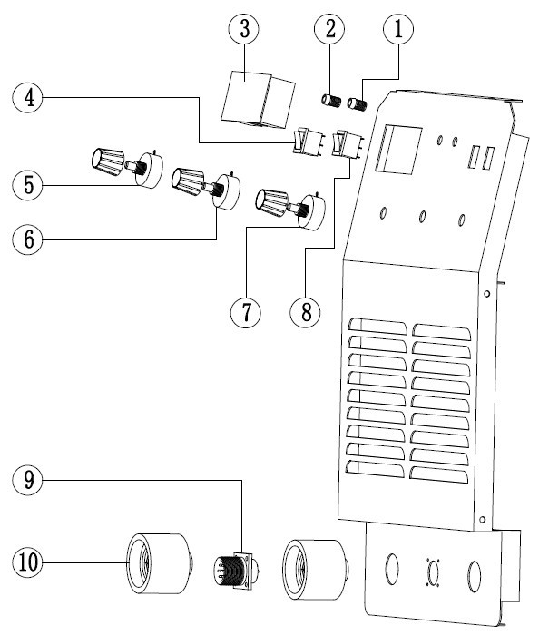
2.Power LED
3.Current meter
4.Remote control/Local switch
5.Hot start current adjust
6.Arc force current adjust
7.Welding current adjust
8.MMA/TIG SWITCH
9.Remote control socket
10.Output quick socket

1.2 Back panel
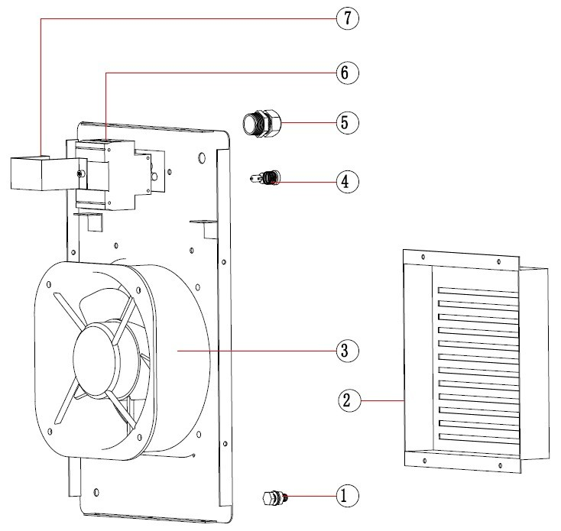
1.Grounding screw
2.Rain cover
3.Axial fan
4.Refuse
5.Cable locker
6.Power switch
7.Power switch support

1.3 Middle plate
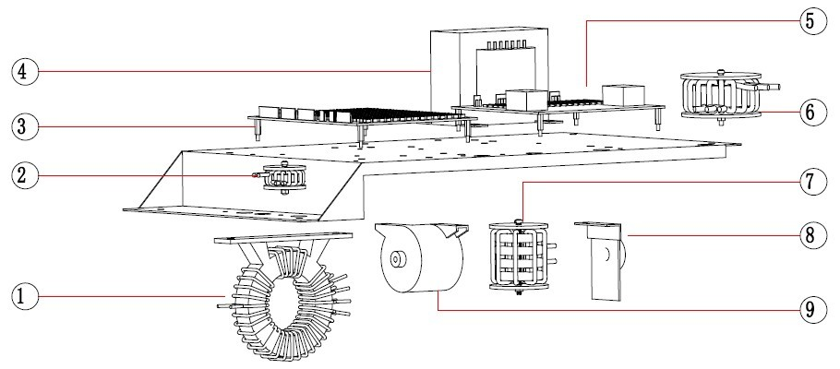

1.Main transformer 2.Feedback signal shielding ring
3.Control PCB 4.Power supply transformer T7
5.Driver PCB 6.Input indcutance
7.Filter indcutance 8.Current feedback board
9.Capacitor
1.4 Heat sink
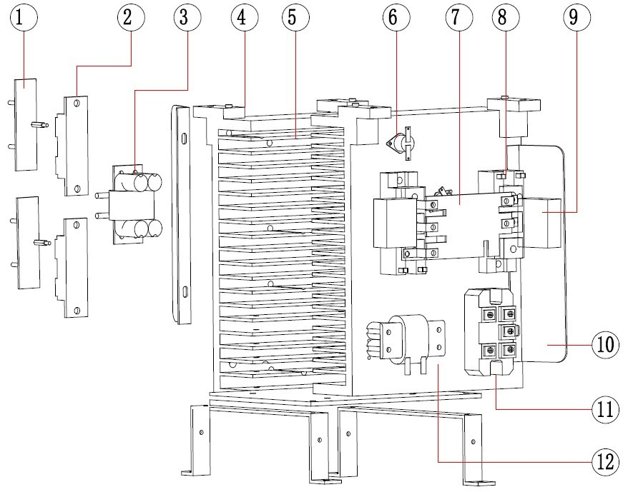
1.Diode absorb plate
2.Fast recovery diode
3.Load coil
4.T type support
5.Heat sink
6.Thermal switch
7.Resonance plate
8.IGBT modual 9.capacitor
10.Wind shield 11.3phs rectifier 12.Filter inductance
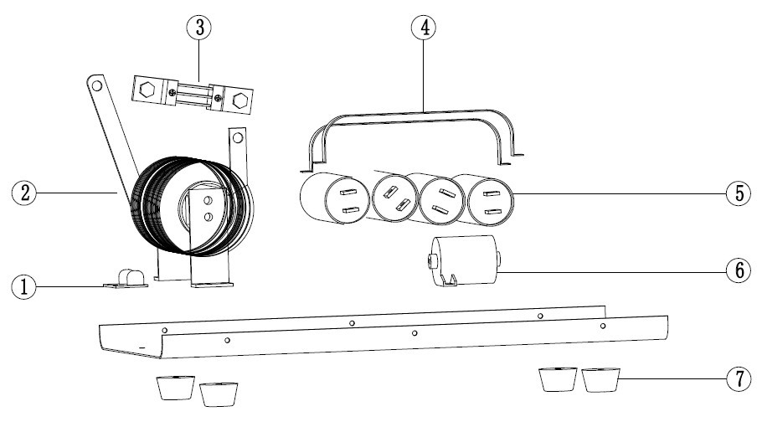
1.5 Bottle plate

- Absorbing curtain 2.Reactor 3.Diverter
4.Capacitor holder 5.Capacitor 50Uf/450V
6.Capacitor 20Uf/1200V 7.Rubber foot

1.6 Repair tools

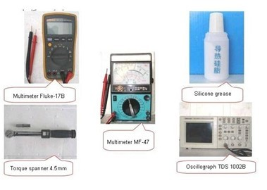

2：CIRCUIT DIAGRAM AND PARTS
2.1a CIRCUIT DIAGRAM
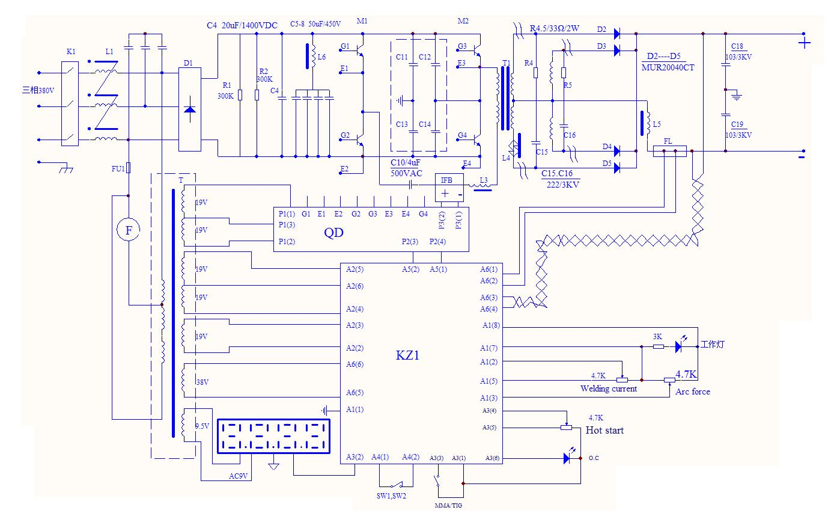

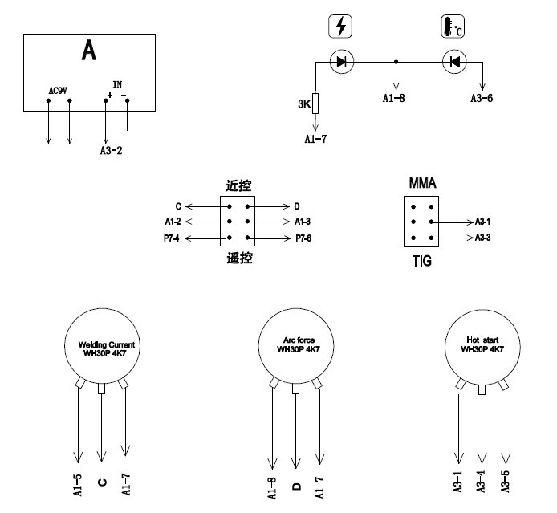
2.1b FRONT PANEL CIRCUIT DIAGRAM

2.2 COMPONENT LIST OF CIRCUIT DIAGRAM
Position | Name | ARC-500 | ARC-400
K1 | Power switch | DZ47-50D(50A/3P) | DZ47-40D(40A/3P)
D1 | 3hs rectifer | MDS100-16 | MDS100-16
L1 | Input inductance | ARC-500-1 | ARC-400-1
L5 | Reactor | ARC-500-2 | ARC-400-2
C5-8 | Capacitor | 50uF±5%/450VAC | 50uF±5%/450VAC
C4 | Capacitor | 20uF±5%1400VDC | 20uF±5%1400VDC
L6 | Filter inductance | ARC500-3 | ARC400-3
C10 | Capacitor | 5.0uF±5%500VAC | 4.0uF±5%500VAC
M1,M2 | IGBT modual | GD100HFL120C2S | GD75HFL120C1S
T1 | Main trasformer | ARC-500-4 | ARC-400-4
T | Power transformer | T7 | T7
D2-D5 | Fast recovery diode | DH2F100N4S | DH2F100N4S
L3 | Converter inductor | ARC-500-5 | ARC-400-5
L4 | Load coil | ARC-500-6 | ARC-400-6
Fu1 | Refuse | 5A(5*20) | 5A(5*20)
 | Knob | A03 bakelite | A03 bakelite
F | Axial fan | TG22580HA2-C | TG22580HA2-C
 | Ship type switch | KCD1-2 | KCD1 -2
 | Ship type switch | KCD1-3 | KCD1 -3
 | Digital meter A | LX9135-1 | LX9135-1
SW1,SW2 | Thermal switch | KSD 70 close | KSD 70 close
 | Potentiometer | WH30P 4K7 | WH30P 4K7
 | Potentiometer | WTH 33K | WTH 33K
KZ1 | Main control PCB | 909237-500 | 909237-400
QD | Driver board | 1004291 | 1004291
FL | Diverter | 500A/75mV | 300A/75mV
 | Fasten connector | DF 50-75 | DF 50-75

2.3 Failure by the damage component
Damage component | Failure phenomenon
FU1 | Digital meter not working，machine no out put
Welding current potentiometer | Welding current not adjust,instability,in max current or min current.
Arc force potentiometer | Welding sitick electrodes ,breaking arc ,welding current instability.
Arc starting potentiometer | Arc starting current instability.
Remote/local control exchange switch | Don’t adjust welding current,digital display shows beating,welding current instability.
MMA/TIG exchange switch | Don’t have no-load voltage.
M1/M2 modual | Don’t have output current,or output current become small.
D2-D6 diode | Don’t have no-load voltage.
QD board | Don’t have output current,or output current become small.
3phs rectifier | Don’t take on the power switch,(shout).
3phs rectifier | Don’t have no-load voltage,(open circuit).

3 Fault repair
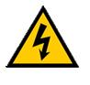
3.1 Warning

Welding machine should be repaid by professional, any error connector and fixing will cause PCB or components damage ，after cut of power ，need to wait a few minutes ，after confirmed input capacitance fully discharge，should can starting repair，pro-tected from electric shock。
3.2 Notes
⑴ Please be Sure to observe the manual notes ,otherwise might occur accident.
⑵ Repair the machine by the professional qualifications staff.
⑶ Repair ,please refer to following tips and maintenance of the fault phenomena, if can not repair, please contact the manufacturer to avoid the spreading of the accident.
⑷ Be fore repair , please make sure the mahine’s power supply is normal.
Did the power supply voltage and frequency same as the nameplates，the Power supply capacity can meet the demand of the machine working ，avoid the welding cable and control cable, wire breakage; prevent welding output short circuit.

3.3 Content prompt
A: Welding current instability --------------------------------------------------------------------------------9
B: Welding current not adjust,too big or too small------------------------------------------------------9
C: Air breaking --------------------------------------------------------------------------------------------------9
D: Air starting is very hard------------------------------------------------------------------------------------10
E: Don’t have no-load voltage ------------------------------------------------------------------------------10
F: Local control is normal,remote control is abnormal------------------------------------------------10
3.4 Repair ways:
A: Welding current instability.
No | Fault cause | Differentiate ways and processing
1 | Power source missing phase？ | Checking 3phs power source
2 | Air switch（K1）broken? | Check each phase of the air switch is good or not
3 | Adjust current potentiometer broken? | Front plate on the machine，check and replace
4 | Remote control wire broken？ | Check and replace
5 | Welding cable too small or too long | Check connect cable or replace
6 | Main control board（KZ） broken？ | Check and replace
7 | Welding cable broken? | Check and replace

B: Welding current not adjust,too big or too small
No | Fault cause | Differentiate ways and processing
1 | Remote wire broken(remote state)？ | Check connect and replace
2 | Current potentiometer broken？ | Replace digital meter
3 | Remote/local exchange switch broken? | Check and replace
4 | Break line inside the machine? | Check and replace connect
5 | Converter inductance L3 broken? | Check and replace
6 | Resonance plate capacitor broken? | Check and replace
7 | IGBT module broken? | Check and replace
8 | Diode (D2-D5) broken? | replace
9 | Driver board (QD) broken? | replace
10 | Main control board（KZ1）broken？ | replace

C: Air breaking.
No | Fault cause | Differentiate ways and processing
1 | 3phs power source missing phase？ | Check and repair
2 | Welding cable break off or not connect good？ | Reliably connected
3 | 3phs rectifier bridge circuit？ | Check and replace
4 | IGBT broken？ | Check and replace
5 | Fast recovery diode（D2-D5） broken? | Check and replace
6 | Arc force current too small? | Increased arc force current given
7 | Main control board（KZ2）,driver board （QD）broken？ | Check and replace

D: Air starting is very hard.
No | Fault cause | Differentiate ways and processing
1 | 3phs power source missing phase？ | Check and repair
2 | The preset current too small？ | Increase welding current given
3 | Main control board（KZ2）,driver board（QD） broken？ | Check and replace
4 | The current adjustment potentiometer broken? | Check and replace
5 | The arc forcre current too small？ | Increase arc force current given
6 | Welding cable too small and too long? | Check and replace

E: Don’t have no-load voltage
No | Fault cause | Differentiate ways and processing
1 | 3phs missing phase ？ | Check and repair
2 | MMA/TIG switch broken? | Check and replace
3 | The power transformer broken？ | Check and replace
4 | Diode (D2-5) broken? | Check and replace
5 | Main control board（KZ2）broken？ | Check and replace
6 | IGBT module broken? | Check and replace

F: Local control is normal,remote control is abnormal.
No | Fault cause | Differentiate ways and processing
1 | Remote control wire disconnect？ | Check and replace connect
2 | Remote/local control switch broken? | Check an replace
3 | Control board（KZ）broken？ | Check an replace

4 Power off measuring

Warning：

- Make sure 3phs power cable are completely out of power, should begin detected the components.
- Welding cable is disconnect from the output terminal.
- After a few minute，check input capacitance，3phs rectifier，IGBT components，make sure full discharges should can begin measuring, to prevent electrical shock.

Note matters：
1. Digital Multimeter state diode / resistor / capacitor gear position
2. Using different multimeter for measuring, the value are different.
3. After the digital stable on the multimeter, should can recorded.
4. Make sure the multimeter’s pen and measurement point in good connector
5. Measurement parts of components need cut off with the control board connector

4.1Conten Prompt：
A: Power transformer T7 measuring
B: The welding current potentiometer measuring
C: The arc force current potentiometer measuring
D: The arc starting current potentiometer measuring
E: MMA/TIG exchange switch measuring
F: Remote/local exchange switch measuring
G: Temperature switch measuring
H: Diverter FL measuring

A: power transformer T7 measuring
No | Trad | Voltage | Remark
1 | 0--1--2 | 0V--220V--380V | Please use multimeter AC voltage automatic gear
2 | 3--4 | 0V--38V | Please use multimeter AC voltage automatic gear
3 | 5--6--7 | 19V--0V--19V | Please use multimeter AC voltage automatic gear
4 | 8--9--10 | 19V--0V--19V | Please use multimeter AC voltage automatic gear
5 | 11--12 | 0V--19V | Please use multimeter AC voltage automatic gear
6 | 13--14 | 0V--9V | Please use multimeter AC voltage automatic gear

B: The welding current potentiometer measuring

Multimeter range | Red pen-shape meter | Black pen-shape meter | Reference value | remark
Resistance stalls auto range | A1(2) | A1(5) | 0-4.7KΩ 5% | Positive and negative adjustment potentiometer should change continuously without hopping
Resistance stalls auto range | A1(2) | A1(7) | 0-4.7KΩ 5%
Resistance stalls auto range | A1(5) | A1(7) | 4-5.5KΩ
Notes：Before measuring，please take off the plug A1 of main control board , Remote / local
controlswitch to local control position, please attention to the resistance value should
change continuously,when you adjust potentiometer.
C: The arc force current potentiometer measuring

Multimeter range | Red pen-shape meter | Black pen-shape meter | Reference value | remark
Resistance stalls auto range | A1(3) | A1(8) | 0-4.7KΩ 5% | Positive and negative adjustment potentiometer should change continuously without hopping
Resistance stalls auto range | A1(3) | A1(7) | 0-4.7KΩ 5%
Resistance stalls auto range | A1(8) | A1(7) | 4-5.5KΩ
Notes：Before measuring，please take off the plug A1 of main control board , Remote / local
controlswitch to local control position, please attention to the resistance value should
change continuously,when you adjust potentiometer.
D: The arc starting current potentiometer measuring

Multimeter range | Red pen-shape meter | Black pen-shape meter | Reference value | remark
Resistance stalls auto range | A3(4) | A3(5) | 0-4.7kΩ 5% | Positive and negative adjustment potentiometer should change continuously without hopping
Resistance stalls auto range | A3(4) | A3(1) | 0-4.7kΩ 5%
Resistance stalls auto range | A3(5) | A3(1) | 4-5.5kΩ
Notes：Before measuring，please take off the plug A1 of main control board , please attention to
the resistance value should change continuously,when you adjust potentiometer.

E: MMA/TIG exchange switch measuring
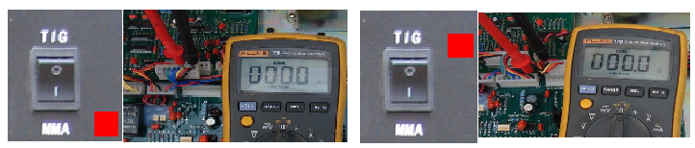

Multimeter range | Red pen-shape meter | Black pen-shape meter | Reference value | remark
Resistance stalls auto range | A3(1) | A3(3) | Y＜1 Ω | TIG state
Resistance stalls auto range | A3(1) | A3(3) | N(∞) | MMA state
Notes：Before measuring，please take off the plug A3 of main control board.

F: Remote/local exchange switch measuring
Introductions:
The main switch signal of remote control and near control as follows:
1. Welding current give the signal
2. Thrust current give the signal
When you choose near control,two signals will be adjusted through potentiometer on the
panel of the machine,and then sent to the control panel.
When you choose remote control.two signals will be adjusted through potentiometer of remote
control,and then sent to the control panel with socket of remote control.
The switch is double gears switch,can be tested on-off with universal meter

G: Temperature switch measuring
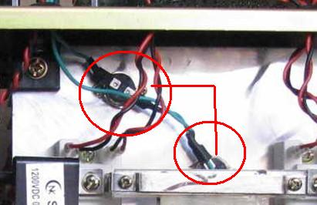

Multimeter range | Red pen-shape meter | Black pen-shape meter | Reference value | remark
Resistance stalls auto range | SW1 | SW2 | Y (<1Ω)
Notes：Before measuring，please take off the plug A4 of main control board.
H: Diverter FL measuring
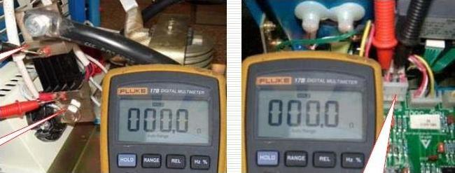

Multimeter range | Red pen-shape meter | Black pen-shape meter | Reference value | remark
Resistance stalls auto range | FL+ | FL- | <0.5Ω | A6(1)—FL+
Resistance stalls auto range | A6(1) | A6(2) | <0.5Ω | A6(2)—FL-
Notes：Before measuring，please take off the plug A6 of main control board.

5 Repair and maintenance
WARNING：

1：Welding machines require professional maintenance
2：The inside of the machine high voltage up to 600V, do not touch live parts; Detect the components in machine,it should completely turn off the power. After take off the power, wait a few minutes, measuring the voltagle on DC bus capacitor ,make sure replacement the components after it completely discharge.
3：IGBT is sensitive to static electricity, static electricity will damage module during the operation process。
4：High power module, screw should be uniform.

8.1 Repair and maintenance
1：Every 3-6 months, professionals people use compressed air to dust removal of welding power source, as well as check the fasteners don’tloosein machine. Every 1 month in bad environment.
2：Three-phase power supply voltages are within 340V-420V, make sure missing phase.
3：Make sure reliable earthing and insulation.
4：Often check cable breakage, disconnection, adjustment knob is loose.
5：Check the cable connection to the welding machine terminals for fastening and reliable, avoid damage to the terminals.
6：Check the contact tip, pressure wire wheel and wire wheel,if it be damaged,it should be replaced, often cleaning wire feed hose, ensure the wire feed flow.
7：Check the welding torch not breakage, disconnection, check gun head, nozzle, gas sieve device is loose, burning.
8：Often check the pipe for damage, whether gas table with frosting, not heating.
9：Keep the welding machine with good ventilation, internal welding machine drying.

