- ARC160
3.1 The structure drawing of ARC160:
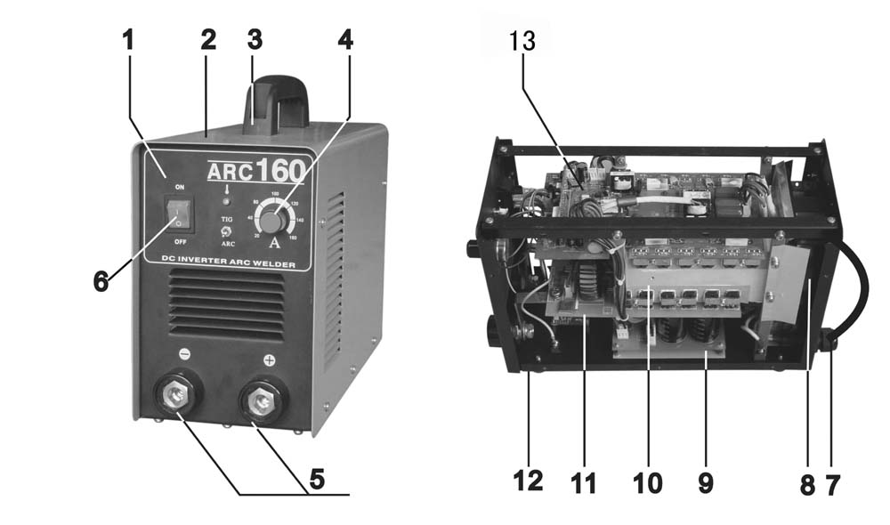

NO. | DESCRIPTION | NO. | DESCRIPTION | NO. | DESCRIPTION
1 | Front panel | 6 | Main switch | 11 | Center PCB
2 | Cover | 7 | Input cable | 12 | Rubber foot
3 | Handle | 8 | Fan | 13 | Top PCB
4 | Button | 9 | Bottom PCB
5 | Coupling socket | 10 | Heat sink

3.2 The general connection diagram of ARC160:
3.3 The diagram of top PCB PM-01-A3, center PCB PD-06-A2 and bottom PCB PZ-04-B0:

3.4 Troubleshooting of ARC160:
Trouble | Analysis | Solution
1. The power indicator is on, but the fan doesn’t work or stops after few turns and no welding voltage output. | - The cable from the power supply switch to bottom PCB is not in good connection.  - Some parts in the auxiliary power supply part on top PCB PM-01-A3 are damaged.  - The relay RELAY1 on bottom PCB PZ-04-B0 doesn’t close well. | - Check the connecting plug.  - Check if resistor R22/R24/R26, zener diode Z3/Z4, MOSFET VT2, OC U2, diode D6/D7/D8/D10 and audion Q1 is damaged with a multi-meter.  - Check and replace it if necessary.
2. Turn on the machine, the fan works, the malfunction LED is not on, but no welding output. | - The thermal switch, which matches the socket CON2 on the top PCB PM-01-A3, is damaged.  - The MOSFET VT3./VT4./VT5./VT6. on the top PCB PM-01-A3 or rectifying diode D2.4/D3.4/D2.1/D3.2/D2.3/D3.3/D3.5 on center PCB PD-06-A2 is damaged. | - Check and replace it if necessary.  - Check with a multi-meter and replace them if necessary. Turn off the machine and disconnect the cable, which matches socket CON8 on the top PCB PM-01-A3, then turn on the machine. If the malfunction LED is on, some MOSFET on the top PCB is damaged, check parts on control module PK-07-B0; if the malfunction LED is not on, some rectifying diode on the center PCB PD-06-A2 is damaged.
3. Turn on the machine, but it trips. | - The rectifying bridge is damaged.  - The capacitor C1/C2/C3/C4 on bottom PCB is damaged. | - Check the rectifying bridge, which matches the socket CON1/CON2 on bottom PCB PZ-04-B0.  - Check and replace it if necessary.
4. The welding current is invariable. | - Audion Q2, variable resistor VR4, resistor R35 on top PCB PM-01-A3, or potentiometer matching socket CON5 is damaged. | - Check with a multi-meter. If the current is too high or too low, adjust the value of the variable resistor VR4.
5. Turn on the machine, the indicator is not on, the fan works, but no no-load voltage output. | - Manostat U3 on top PCB PM-01-A3 or some part on control module PK-02-A1 is damaged.  - The MOSFET VT7/VT8/VT9/VT10 on top PCB PM-01-A3 is damaged. | - Check with a multi-meter.  - Check.

4. ARC200
4.1 The structure drawing of ARC200:

The structure of ARC200 is similar to that of ARC160. (See the structure drawing of ARC160 on page 12.)
4.2 The general connection diagram of ARC200:
4.3 The diagram of top PCB PM-22-A0 and bottom PCB PZ-10-B0:
4.4 Troubleshooting of ARC200:

Trouble | Analysis | Solution
1. Turn on the machine, the power indicator is on, but the fan doesn’t work or stops after few turns and no welding output. | - The cable from the power supply switch to bottom PCB is not in good connection.  - Some parts in the auxiliary power supply part on top PCB PM-22-A0 are damaged.  - The relay RELAY1 on bottom PCB PZ-10-B0 doesn’t close well. | - Check the connecting plug.  - Check if resistor R22/R24/R26, zener diode Z3/Z4, MOSFET VT2, OC U2, diode D6/D7/D8/D10 and audion Q1 is damaged with a multi-meter.  - Check and replace it if necessary.
2. Turn on the machine, the fan works, the malfunction LED is not on, but no welding output. | - The thermal switch, which matches the socket CON2 on the top PCB PM-22-A0, is damaged.  - The MOSFET VT3./VT4./VT5./VT6. on the top PCB PM-22-A0 or rectifying diode D2.4/D3.4/D2.1/D3.2/D2.3/D3.3/D3.5 on center PCB PD-06-A2 is damaged. | - Check and replace it if necessary.  - Check with a multi-meter and replace them if necessary. Turn off the machine and disconnect the cable, which matches socket CON8 on the top PCB PM-22-A0, then turn on the machine. If the malfunction LED is on, some MOSFET on the top PCB is damaged, check parts on control module PK-07-B0; if the malfunction LED is not on, some rectifying diode on the center PCB PD-06-A2 is damaged.
3. Turn on the machine, but it trips. | - The rectifying bridge is damaged.  - The capacitor C1/C2/C3/C4/C5/C6 on bottom PCB is damaged. | - Check the rectifying bridge, which matches the socket CON1/CON2 on bottom PCB PZ-10-B0.  - Check and replace it if necessary.
4. The welding current is invariable. | - Audion Q2, variable resistor VR4, resistor R35 on top PCB PM-22-A0, or potentiometer matching socket CON5 (XH-03) is damaged. | - Check with a multi-meter. If the current is too high or too low, adjust the value of the variable resistor VR4.
5. Turn on the machine, the malfunction LED is not on, the fan works, but no no-load voltage output. | - Manostat U3 on top PCB PM-22-A0 or some part on control module PK-02-A1 is damaged.  - The MOSFET VT7/VT8/VT9/VT10 on top PCB PM-22-A0 is damaged. | - Check with a multi-meter.  - Check.

5. ARC200B
5.1 The structure drawing of ARC200B:

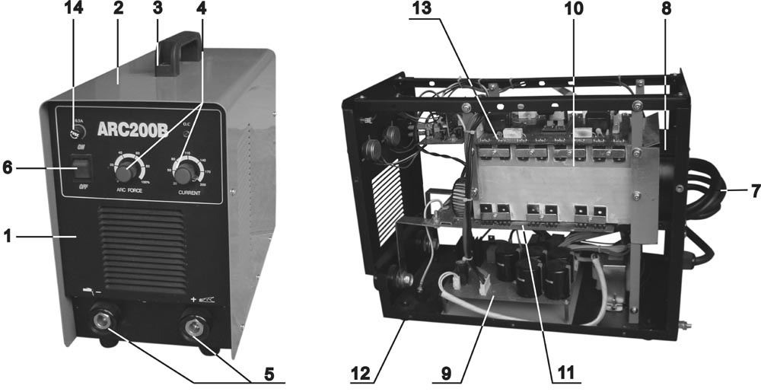

NO. | DESCRIPTION | NO. | DESCRIPTION | NO. | DESCRIPTION
1 | Front panel | 6 | Main switch | 11 | Center PCB
2 | Cover | 7 | Input cable | 12 | Rubber foot
3 | Handle | 8 | Fan | 13 | Top PCB
4 | Button | 9 | Bottom PCB | 14 | Fuse
5 | Coupling socket | 10 | Heat sink

5.2 The general connection diagram of ARC200B:
5.3 The diagram of top PCB PM-16-A0, center PCB PD-19-C0 and bottom PCB PZ-13-A1:

5.4 Troubleshooting of ARC200B:
Trouble | Analysis | Solution
1. Turn on the machine, the power indicator is not on, and the fan doesn’t work. | - The input cable doesn’t match CP1 and CP2 on bottom PCB PZ-13-A1 well  - The power supply switch is damaged. | - Check.  - Check and replace it if necessary.
2. Turn on the machine, the power indicator is on, but the fan doesn’t work, and no welding output. | - The voltage of socket CON1 on bottom PCB PZ-13-A1 is abnormal.  - Some parts on the bottom PCB PZ-13-A1 are damaged.  - The connecting cable, which supplies power for top PCB PM-16-A0, doesn’t match the socket CON7 well. | - Check if the auxiliary transformer is damaged.  - Check if the rectifying bridge BR1, manostat U1, MOSFET VT1, or the relay RELAY1/RELAY3 is damaged.  - Check.
3. Turn on the machine, the power indicator is on, the fan works, but no no-load voltage output. | - MOSFET VT9/VT10/VT11/VT12 or manostat U1 on top PCB PM-16-A0 is damaged.  - Some parts on control module PK-03-A1 at P1 position of top PCB is damaged. | - Check and replace it if necessary.  - Check.
4. Turn on the machine, but the malfunction LED is on. | - The thermal switch, which matches the socket CON5 on top PCB, is damaged.  - MOSFET VT1/VT2/VT3/VT4/VT5/VT13/  VT14/VT15/VT16/VT17/VT18/VT19/VT20 on top PCB PM-16-A0 is damaged.  - Rectifying diode U1/U2/U—U10/U11/U12 on center PCB PD-19-C0 is damaged. | - Check and replace it if necessary.  - Check and replace it if necessary.  - Check with a multi-meter and replace it if necessary.
5. The welding current is invariable. | - The current potentiometer doesn’t match socket CON4 on top PCB well or it’s damaged.  - The variable resistor VR2 or the resistor R18 on top PCB is damaged.  - The connecting cable from socket CON2 on top PCB to socket CON1 on center PCB is in loose connection. | - Check and replace it if necessary.  - Check and replace them if necessary. Adjust the value of variable resistor VR2 to change the current.  - Check.
6. Turn on the machine, but it trips. | - The rectifying bridge which matches socket CON3/CON6 on bottom PCB PZ-13-A1 is damaged. | - Check.

6. ARC250
6.1 The structure drawing of ARC250:
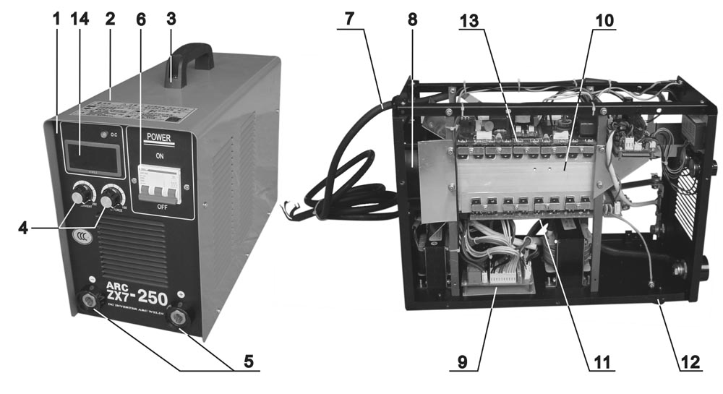

NO. | DESCRIPTION | NO. | DESCRIPTION | NO. | DESCRIPTION
1 | Front panel | 6 | Main switch | 11 | Center PCB
2 | Cover | 7 | Input cable | 12 | Rubber foot
3 | Handle | 8 | Fan | 13 | Top PCB
4 | Button | 9 | Bottom PCB | 14 | Digital meter
5 | Coupling socket | 10 | Heat sink

6.2 The general connection diagram of ARC250:

6.3 The diagram of ARC250’s control PCB PK-05-A4 and control module PK-03-A1:
6.4 Troubleshooting of ARC250:
Trouble | Analysis | Solution
1. No display on the meter; turn on the machine, but no response. | - The input voltage is abnormal; the input cable is not in good connection.  - The power switch is not on; no 3-phase voltage input.  - No DC24V voltage output by the auxiliary power supply; the transformer or supplementary power supply is damaged. | - Check.  - Check.  - Check with a multi-meter if the output voltage of transformer matching socket CON9 on control PCB PK-05-A4 is normal; if manostat U7/U8, chip U6, MOSFET U1, or resistors on the PCB is damaged.
2. Turn on the machine, it appears normal, but the red pilot lamp turns on once welding is carried out. | - The connecting cable doesn’t match the socket CON11 on control PCB PK-05-A4 well, or some parts on control module PK-03-A1 are damaged.  - Loose connection exists in main input cable. | - Check with a multi-meter if the chip U2 or audion Q9 is damaged.  - Check.
3. Normal display on the meter, the fan works, but no welding output and the red pilot lamp is not on. | - Loose connection exists inside the machine.  - The thermal switch matching socket CON8/CON9 on control PCB PK-05-A4 is damaged.  - MOSFET U2/U3/U4/U5 on control PCB PK-05-A4 is damaged.  - Some parts on control module PK-03-A1 is damaged. | - Check.  - Check.  - Check.  - Check if the 15th pin’s voltage of chip U1 is +12V and 16th pin’s is +5V with a multi-meter. If the 15th pin’s is not +12V, replace the manostat on PK-05-A4 because it’s damaged. If the 16th pin’s is not +5V, replace the chip because it’s damaged. Then check if the audion Q2/Q3/Q4/Q5/Q7/Q8 is damaged.
4. Normal display on the meter, the fan works, Turn on the machine, but the malfunction LED is on. | - Malfunction of inverter exists. | - Check with a multi-meter one by one if the MOSFET on top PCB PM-02-A2 or rectifying diode D92-02 on PD-08-B0 is damaged. Turn off the machine and disconnect the cable, which matches the transformer on center PCB with top PCB (near the socket CON1 of the fan), then turn on the machine. If the malfunction LED is on, MOSFET on the top PCB is damaged; if it’s not on, rectifying diode on the center PCB PD-06-A2 is damaged.
5. Wrong display on the meter. | - The connection of meter is loose.  - The value of variable resistor R9 on control PCB PK-05-A4 is inappropriate. | - Check.  - Make sure that short circuit occurs in the 1st and 2nd pins of socket CON6. Adjust the value of current potentiometer matching socket CON2 to the max position. Then adjust the value of R9 to assure the appropriate LED monitor display. To change the min LED display, connect a resistor of appropriate value parallel or in serial with R2.
6. The welding current is invariable or unstable. | - The potentiometer matching socket CON2 on control PCB PK-05-A4 is damaged, or the 1st/2nd pin of socket CON6 is in wrong short circuit condition.  - The resistor R1/R6 on control PCB is damaged.  - Electrolytic capacitor on bottom PCB PZ-01-B0 is damaged. | - Check.  - Check and adjust the value of variable resistor R1 to change the current.  - Check and replace it if necessary.

