MIG series Manual

Marks：Standard by MIG-400

TABLE OF CONTENTS

1：MACHINE STRUCTURE-------------------------------------------------3
2：CIRCUIT DIAGRAM AND PARTS-------------------------------------5
3：FAULT SERVICE-----------------------------------------------------------8
4：POWER-OFF MEASURING-------------------------------------------17
5：POWER-ON MEASURING---------------------------------------------24
6: WIRE FEEDER MEASURING----------------------------------------78
7：MIG TORCH----------------------------------------------------------------34
8：REPAIR AND MAINTENANCE ---------------------------------------36

1.1 Front pane
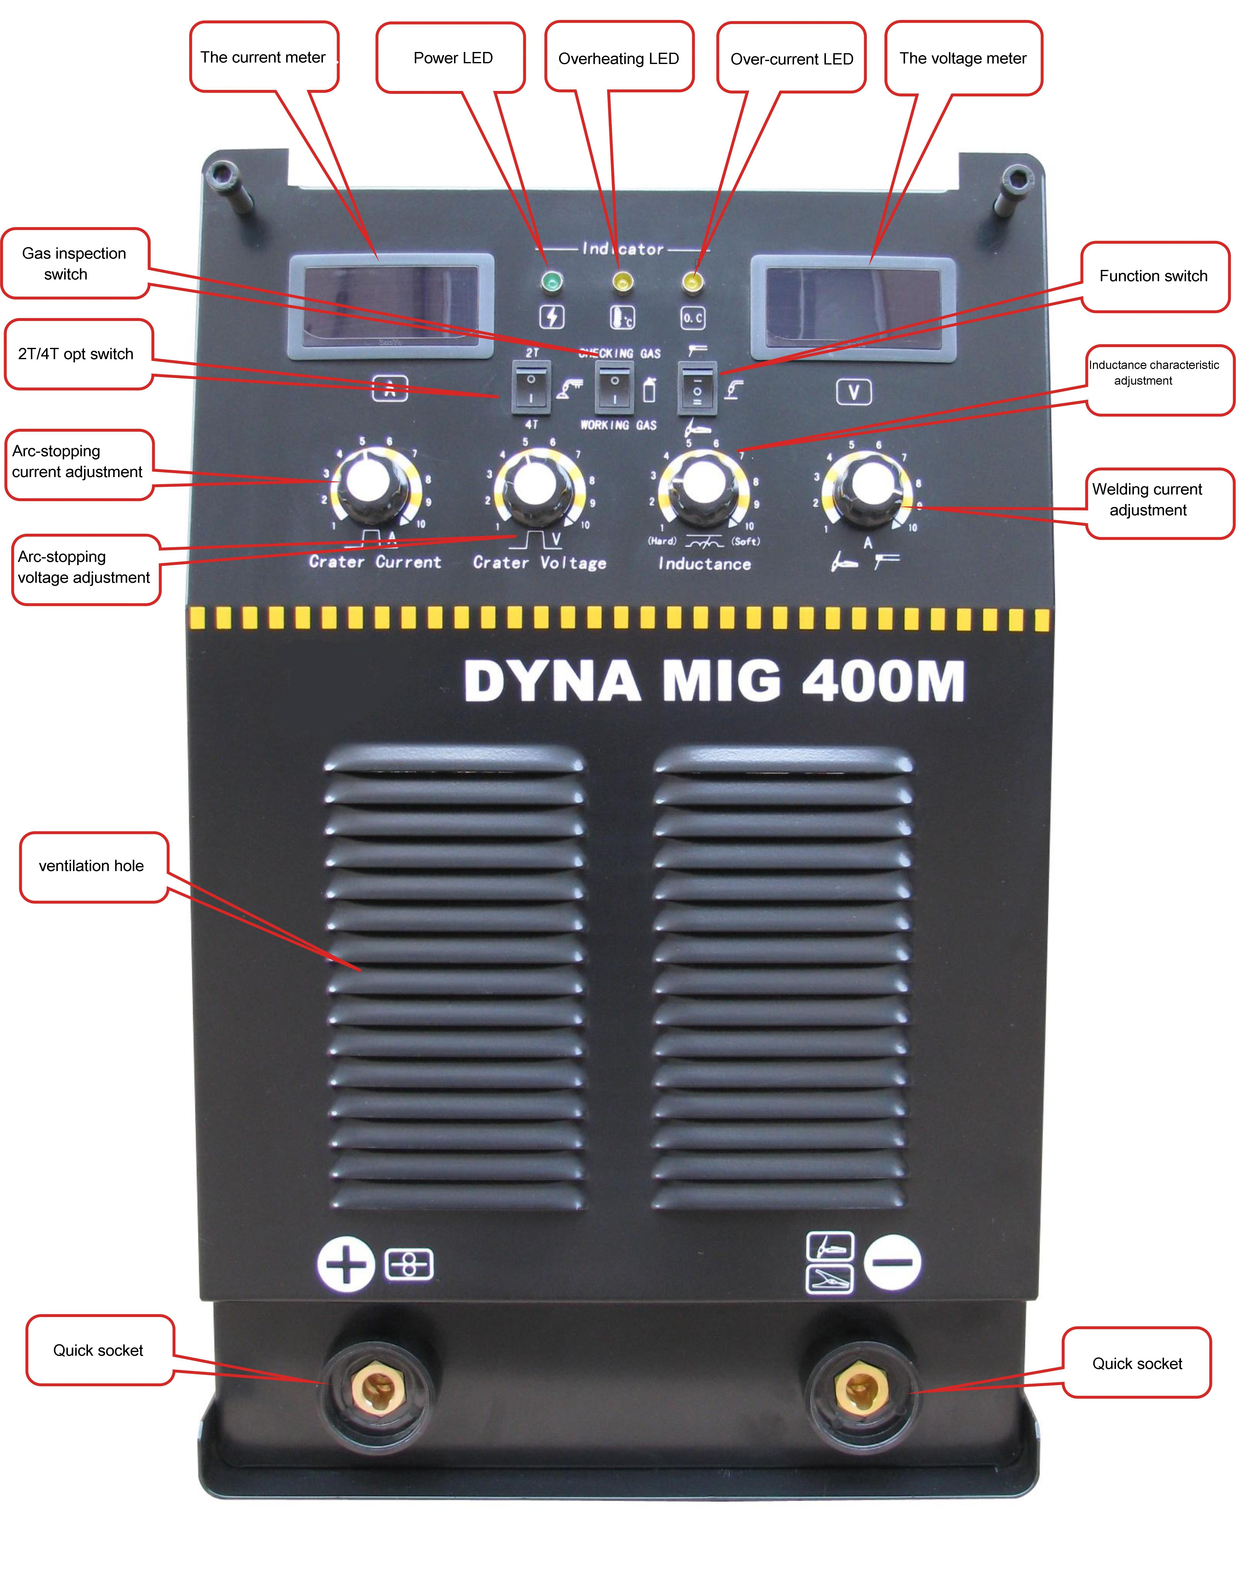
1.2 Back panel
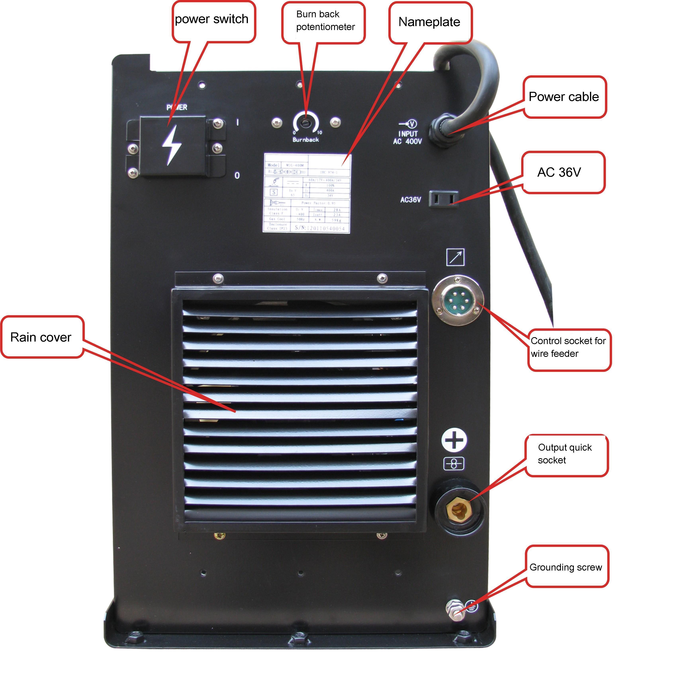

1.3 Top side
1.4 Right side
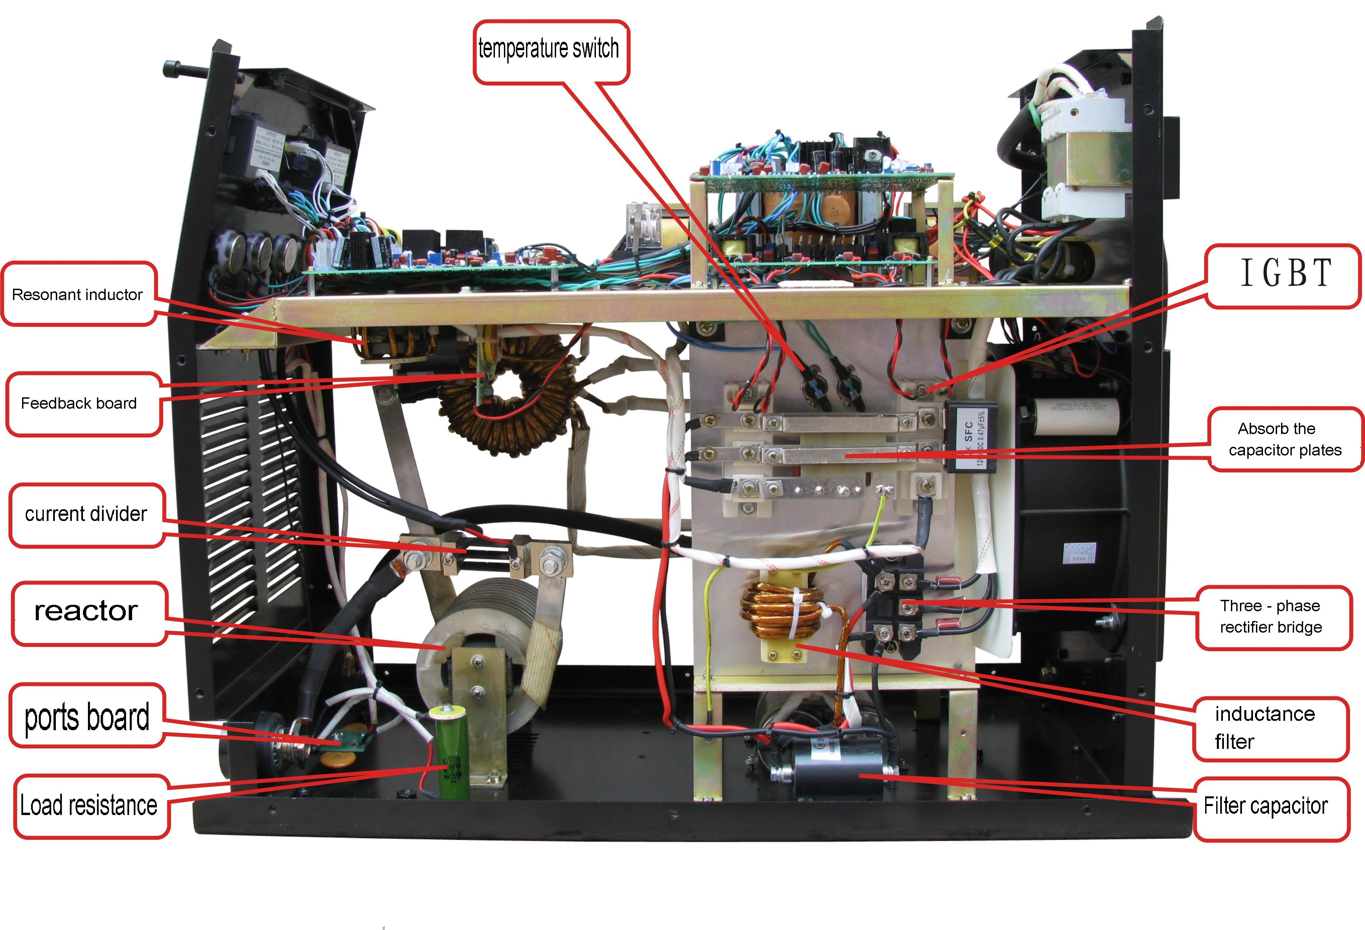
1.5 Left side
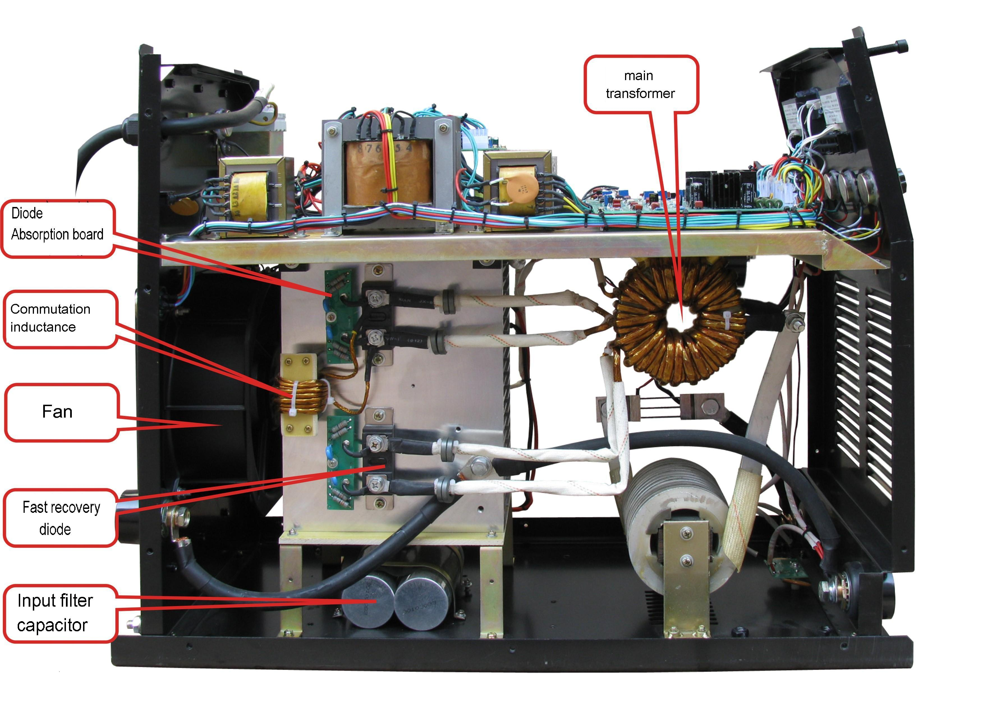
1.6 Repair tools
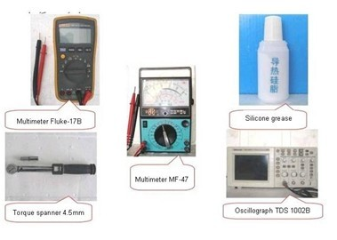

2.1a CIRCUIT DIAGRAM
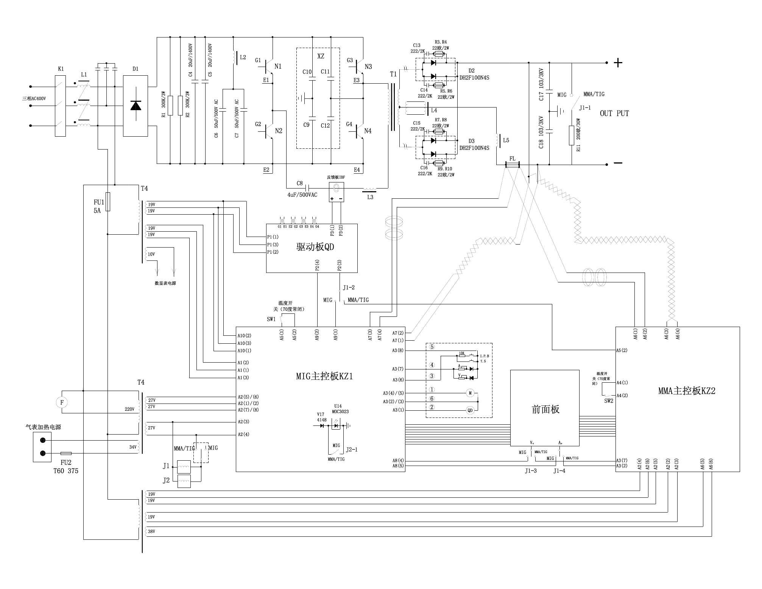

2.1b FRONT PANEL CIRCUIT DIAGRAM
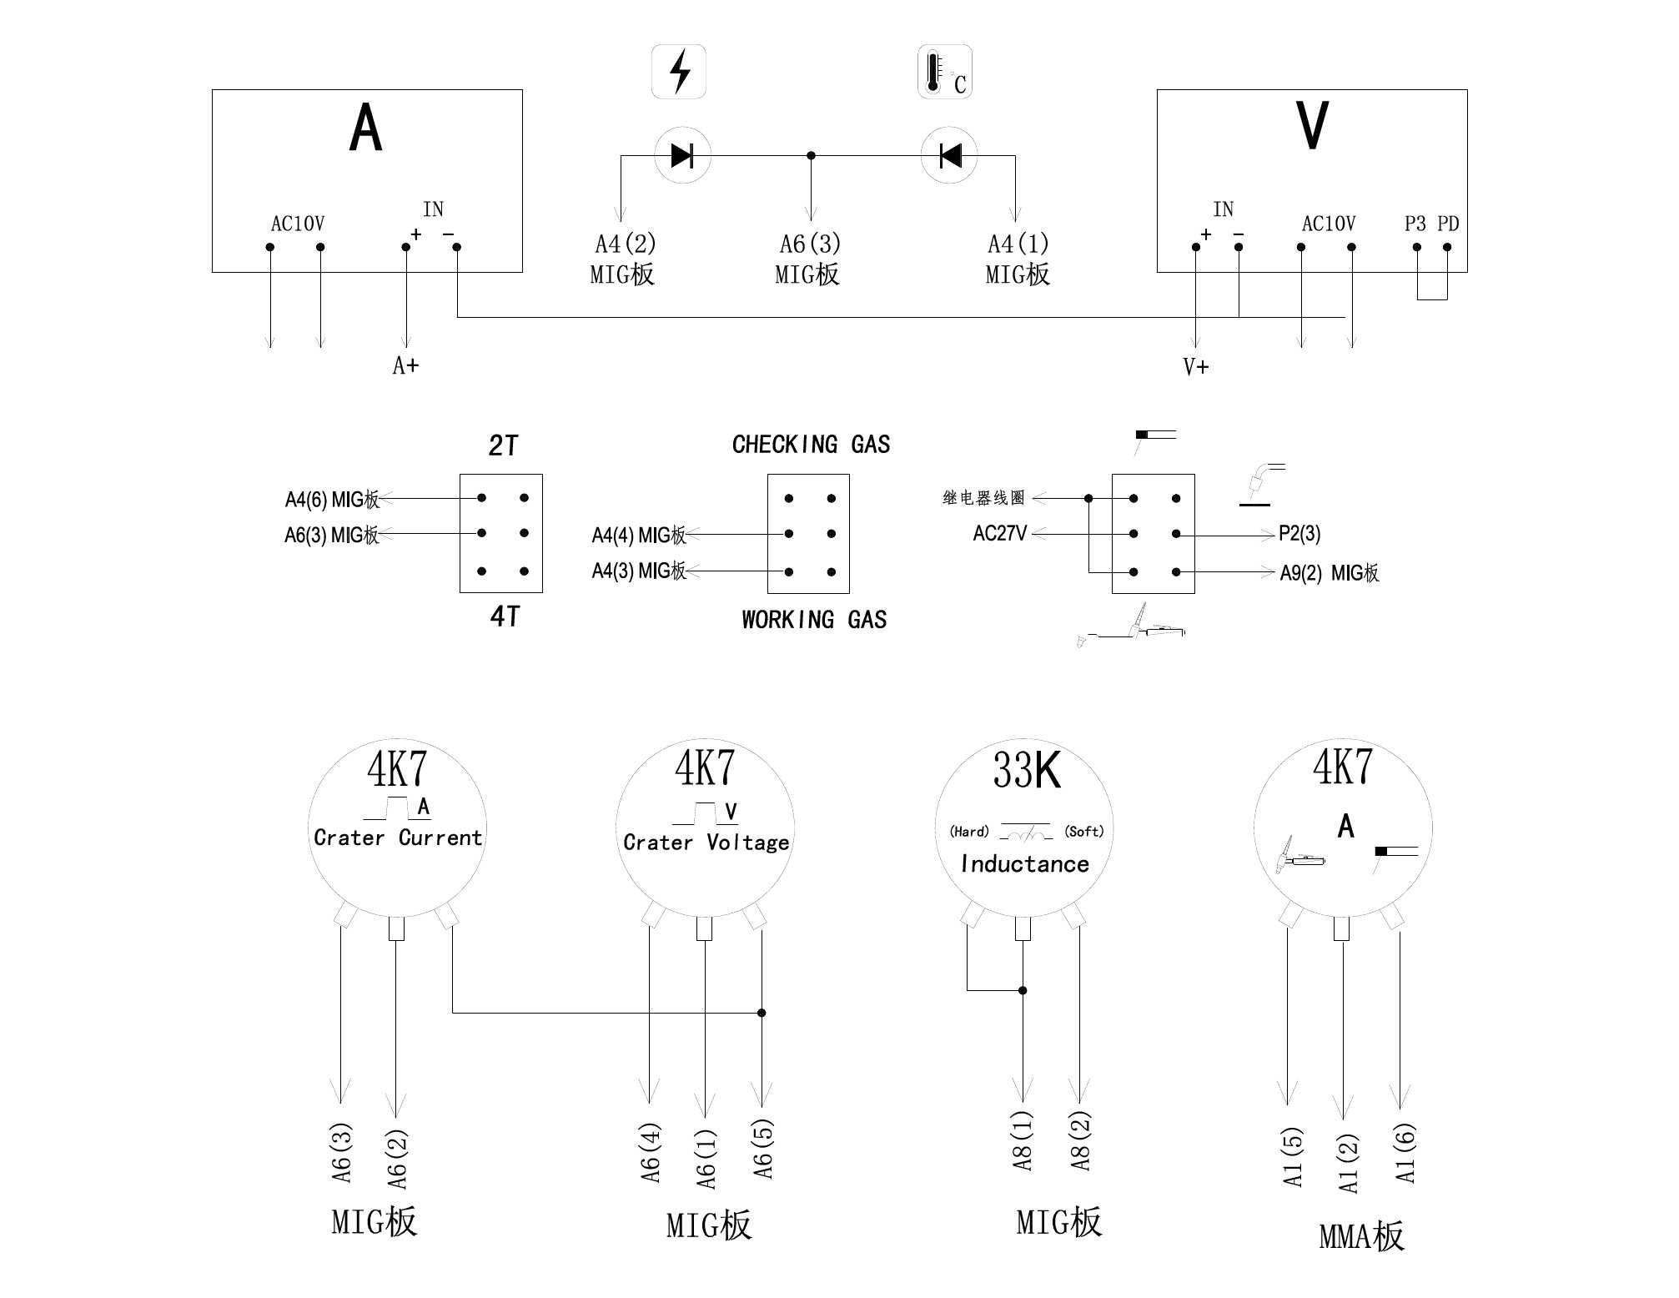

2.2 COMPONENT LIST OF CIRCUIT DIAGRAM
Position | Description | Model
C4,C5 | Polypropylene capacitors | 20UF/1400V DC
C6,C7 | Polypropylene capacitors | 50UF/450V AC
C8 | Polypropylene capacitors | 4UF/500V AC
D1 | 3phs rectifier bridge | MDS100-16
D2,D3 | Fast recovery diodes | DH2F100N4S
FU1 | Power fuse | 5A
FU2 | Heaters | T60 375
IFB | Feedback board | MIG-350
XZ | Absorb capacitor board | MIG-350
L1 | Inductance | MIG-350
L2 | Filter inductance | MIG-350
L3 | Syntony inductance | MIG-350
L4 | Inversion inductance | MIG-350
L5 | Out put reactor | MIG-350
F | Axial flow fan | TG22580HA2(AC220V)
G1,G2,G3,G4 | IGBT | GD75HFL120C1S
+,- | Out put terminal | DKM35-50
QD | Driver board | MIG-350
KZ1 | Control board | MIG-350
KZ2 | Control board | ARC400
T1 | Main transformer | MIG-350
T3 | Power transformer | T3
T4 | Power transforme | T4
T5 | Power transforme | T5
SW1,SW2 | Temperature switch | Closed 70°
FL | Shunt | 300A/75Mv
J1,J2 | Relay | HH52P(AC24V)
K1 | Air switch | DZ47 D40A

2.3 Failure by the damage component
Damage component | Failure phenomenon
FU1 | Digital meter not working，machine no out put
FU2 | CO2 heaters is not heating
Contac tip | Welding current instability，big spatter，poor of molding，instability wire feed，Wire sticking contact tip
Wire feed hose | Welding current instability，big spatter，poor of molding，instability wire feed
Wire feeder wheel | Welding current instability，big spatter，poor of molding，instability wire feed, no wire feed
Wire feed tractor | No wire feed，Intermittent wire feed
Torch switch | Machine not working，press switch wire feed too speed，boot-strap wire feed
Control cable（6pins） | Burn main control board, Current and voltage can not be adjusted，no wire feed，gas valve not working，press torch witch the machine not worling
Voltage feedback line off | MIG state，Max out put voltage，can not adjustted
Current feedback line off | MIG state，slow wire feed，current instability
Current feedback line off | MMA state，Max out put voltage，can not adjustted

3 Fault repair
3.1 Warning

Welding machine should be repaid by professional, any error connector and fixing will cause PCB or components damage ，after cut of power ，need to wait a few minutes ，after confirmed input capacitance fully discharge，should can starting repair，pro-tected from electric shock。
3.2 Notes
⑴ Please be Sure to observe the manual notes ,otherwise might occur accident.
⑵ Repair the machine by the professional qualifications staff.
⑶ Repair ,please refer to following tips and maintenance of the fault phenomena, if can not repair, please contact the manufacturer to avoid the spreading of the accident.
⑷ Be fore repair , please make sure the mahine’s power supply is normal.
Did the power supply voltage and frequency same as the nameplates，the Power supply capacity can meet the demand of the machine working ，avoid the welding cable and control cable, wire breakage; prevent welding output short circuit.

3.3 Content prompt
MIG state
A: After starting machine power light is off, digital meter not show --------------------------------9
B: Digital meter display abnormal -------------------------------------------------------------------------10
C: Starting display normal ,but can not welding ，no voltage current output--------- --------10
D: MIG torch or welding cable too hot--------------------------------------------------------- -----------10
E: No wire feed---------------------------------------------------------------------------------- ---------------10
F: Tractor rotation，but can not wire feed ----------------------------------------------------------------11
G: Instability wire feed -----------------------------------------------------------------------------------------11
H: After energized ,no press torch switch, automatic wire feed--------------------------------------11
I: Speed wire feed in welding process, can not welding -------------------------- --------------------11
J: In actually welding process, welding current instability --------------------------------------------12
K: Welding current、Mix voltage，can not adjustment ，no fuse ---------------------------------12
L: Welding current 、Max voltage，can not adjustment ---------------------------------------------12
M: Welding produce bubbles, gas hole -------------------------------------------------------------- ----13
N: Shallow melting depth rate, weld-seam too high ---------------------------------------------------13
O: Big splash, welding wire burst, hard of forming ----------------------------------- -----------------13
P: Strike fire between the nozzle and the workpiece --------------------------------------------------14
Q: Gas impassable or gas small flow -------------------------------------------------------------------14
R: Long ventilation ----------------------------------------------------------------------------------------------14
S: CO2 Gas regulator without heating ---------------------------------------------------------------------14
T: Overheat lights on，can not welding --------------------------------------------------------------------15
U: After electricity，air switch（K1）trip--------------------------------------------------------------------15

MMA/TIG states
A: After starting machine power light is off, digital meter no display ------------------------15
B: Digital meter display abnormal --------------------------------------------------------------------15
C: Starting machine normal ,but can not weldin，no voltage output ------------------------16
D: Starting machine normal , False output voltage，welding rod contact with the workpiece，have small spark, but can not welding------------------------------------------------------------------------16
E: Big splash in welding, bad forming ---------------------------------------------------------------16
F: Max welding current，can not adjustment ------------------------------------------------------16
G: Min welding current ，can not adjustment ------------------------------------------------------17
3.4 Repair ways:
MIG states A: After starting machine power light is off, digital meter not show
No | Fault cause | Differentiate ways and processing
1 | Power source missing phs ？ | Check the 3phs input power
2 | Air switch broken（K1）? | Check the 3phs input power
3 | Fuse is blown（FU2）? | Inside the machine, check and replace
4 | T4 Power transformer broken？ | check and replace（refer to 4.1A，5.1A）
5 | Power switch broken？ | Check and replace
6 | Digital meter broken or connect line loose? | Check connect line and replace
7 | Main control board（KZ1）broken？ | Check and replace
MIG states B: Digital meter display abnormal
No | Fault cause | Differentiate ways and processing
1 | J1 relay contact not good？ | Check and replace
2 | Feeder cable connection not good or short-term？ | Recovery or replace（refer to 6.2）
3 | Remote control box broken？ | Check and replace（refer to 6.2，6.3）
4 | Digital meter broken？ | Replace digital meter
5 | Main control board （KZ1）broken？ | Replace

MIG states C: Starting machine normal, but can not welding ，no voltage current out put
No | Fault cause | Differentiate ways and processing
1 | Welding cable break or not connect good？ | Reliable connection
2 | 3phs rectifier bridge short circuit？ | Check and replace
3 | IGBT broken？ | Check and replace
4 | Fast recovery diode（D2,D3）broken? | Check and replace
5 | Absorbing capacitor board（XZ）broken？ | Check and replace
6 | Main control board（KZ1）,driver board（QD） broken？ | Check and replace

MIG States D:MIG torch or welding cable too hot
No | Fault cause | Differentiate ways and processing
1 | Welding current too large？ | Change welding torch
2 | Welding cable too small or not connect good？ | Tight connect or change welding cable
3 | Loose contact tip？ | Tight contact tip

MIG State E: No wire feed
No | Fault cause | Differentiate ways and processing
1 | Torch switch damage、short circuit？ | Repair or replace
2 | Wire feeder control cable connector not good？ | Check control cable line1#，6#
3 | Wire feeder tractor damage？ | Check and replace
4 | Power transformer T4 damage？ | Check and replace
5 | Main control board (KZ1)damage? | Check and replace
MIG state F:Tractor rotation，can not wire feed
No | Fault cause | Differentiate ways and processing
1 | Wire fuse with the contact tip？ | Change contact tip
2 | The wheel’s slot not suitable for the wire？ | Change wire feeder wheel
3 | The wheel’s pressure not enough，wheel slipping？ | Adjust wire feeder wheel’s pressure
4 | Wire feed’s tube block？ | Clean or replace the wire feed tube
5 | The Wire bending deformation？ | Cutting the wire，install wire again

MIG state G: Wire feed instability
No | Fault cause | Differentiate ways and processing
1 | The current and voltage not match？ | Adjust current and voltage
2 | The quality of wire is not good？ | Change the wire
3 | Contact tip serious wear and tear？ | Change contact tip
4 | Wire feeding tube’s quality problem not matching with the diameter | Change wire feed’s tube
5 | Welding torch bending diameter＜300mm ? | Straightened troch
6 | pressure wire wheels too loose or too tight？ | Adjust the wheel’s pressure
7 | The wheel wear and tear？ | Change the wheel
8 | Wire feeder’s control connect not good | Checking and resume
9 | Wire feeder’s tractor damage？ | Check and replace
10 | Main control board（KZ1）damage？ | Check and replace

MIG state H: After energized ,no press torch switch, automatic wire feed
No | Fault cause | Differentiate ways and processing
1 | torch switch line short-circuited？ | Check and repair
2 | Control plug socket short-circuited？ | Check and repair
3 | Main control board（KZ1）broken？ | Check and repair

MIG state I: during welding wire feed too fast, can not welding
No | Fault cause | Differentiate ways and processing
1 | Torch switch connect not good？ | Check and replace
2 | Wire feeder control cable short circuit ？ | Check and repair
3 | Control board（KZ1）damage？ | Check and replace

MIG state J: Actually during welding ，Welding current instability
No | Fault cause | Differentiate ways and processing
1 | Welding current voltage adjust not matching？ | Re-adjust the parameter
2 | Missing phase or the voltage of 3phs instability？ | Checking power source
3 | Out put cable connect not good？ | Checking and resume
4 | Wire feed instability？ | Refer to 3.3G
5 | Control box’s potentiometer broken？ | Check and replace
6 | The shunt’s （FL） feedback line connect not good.？ | Check and repair
7 | Main control board（KZ1）broken？ | replace

MIG State K: welding current、mix voltage，can not adjust，no fuse
No | Fault cause | Differentiate ways and processing
1 | Welding cable break off？ | Check and repair
2 | Control box’s potentiometer damage ？ | Check and replace
3 | Inductance potentiometer（L）broken？ | Check and replace
4 | Machine inside voltage, current feedback off line？ | Check and repair
5 | IGBT broken？ | Check and replace
6 | Fast recovery diode（D2、D3） broken？ | Check and replace
7 | Main circuit short circuit or not connect good？ | Check and repair
8 | Line’s of feedback board（IBF） not connect good？ | Check and repair
9 | Main control board（KZ1）or driver board（QD） broken？ | Check and replace

MIG state L:welding current、Max voltage，can not adjustment
No | Fault cause | Differentiate ways and processing
1 | Control box’s potentiometer damage？ | Check and replace
2 | Machine inside voltage, current feedback off line？ | Check and repair
3 | Control board（KZ1）broken？ | Check and replace

MIG state M: Welding produce bubbles, gas hole
No | Fault cause | Differentiate ways and processing
1 | Welding voltage too high？ | Adjust the appropriate voltage
2 | Workpiece or welding wire rust, oil？ | Clear the workpiece and wire
3 | Spatters sticky one the nozzle, gas can not flowing？ | Clear the spatters
4 | Wire extend too long？ | Keep a suitable length during welding
5 | Gas flow is inappropriate？ | Adjusting the gas flow and keep clean
6 | The gas impure , have water？ | Change the gas
7 | Gas calve broken？ | Replace gas valve
8 | Main control board（KZ1）broken？ | Check and replace

MIG state N: Shallow melting depth rate, weld-seam too high
No | Fault cause | Differentiate ways and processing
1 | Welding current voltage not matching？ | Adjust appropriate current voltage welding
2 | Wire extend not inappropriate？ | Keep a suitable length during welding
3 | Contact tip too short？ | Change contact tip
4 | Inductance（L）adjust inappropriate？ | Adjust the appropriate parameters.
5 | Mai control board（KZ1）broken？ | Check and change

MIG state O: Big splash, welding wire burst, hard of forming
No | Fault cause | Differentiate ways and processing
1 | Welding voltage and current specifications inappropriate？ | Adjust appropriate current voltage welding
2 | The inductance（L）adjustment too small？ | Increasing inductance
3 | Connect reversed polarity？ | Change the polarity
4 | CO2 gas impurity？ | Change gas
5 | Workpiece or welding wire rust, oil？ | Clear the workpiece and wire
6 | Torch angle is too large？ | Adjust torch angle
7 | Wire extend too long？ | When welding adjust the distance
8 | Contact tip serious wear and tear？ | Change contact tip
9 | Machine inside voltage, current feedback connect not good？？ | Reliable connection
10 | Main control board（KZ1）fault？ | Check and change

MIG state P: Strike fire between the nozzle and the workpiece
No | Fault cause | Differentiate ways and processing
1 | Spatter accumulation between the nozzle? | Clean Spatter
2 | Conductive rod and nozzles short circuit？ | Check the circuit phenomenon
3 | Nozzle insulation burn? | Check and change

MIG state Q: gas block or gas flow is small
No | Fault cause | Differentiate ways and processing
1 | Severity air leakage？ | Change gas tube
2 | gas bottle pressure too low？ | Change the gas bottle
3 | The spatter obstruction gas nozzle？ | Cleaning nozzle’s spatter
4 | Reducing valve to freeze or broken？ | Connected preheat power or replace Reducing valve
5 | Solenoid valve's air inlet was blockage.？ | Removing foreign
6 | The valve’s spring is block unable to close？ | Open valve change the spring
7 | Solenoid valve is shorted or damaged | Change the gas valve
8 | Main control board（KZ1）broken？ | Check and change

MIG state R: Long ventilation
No | Fault cause | Differentiate ways and processing
1 | Move panel switch to the gas inspect position ? | Adjust switch’s position
2 | The valve jacking up by the foreign matter ？ | Open the valve checking and repair
3 | Main control board（KZ1）broken？ | Check and change it

MIG state S:CO2 Gas regulator not heating
No | Fault cause | Differentiate ways and processing
1 | Gas regulator broken？ | Change and repair
2 | Regulator’s power socket damage？ | Replace
3 | Fuse FU2 broken ？ | Replace
4 | Regulator’s power socket connect line off.？ | Check and repair
5 | Transformer T5 broken？ | Check and replace

MIG state T: Overheating light on, can not welding
No | Fault cause | Differentiate ways and processing
1 | Big current welding in a long time？ | Reduce the welding current
2 | Fan broken？ | Check and replace
3 | Temperature switch broken？ | Check and replace

MIG state U: After power up, the air switch (K1) trip
No | Fault cause | Differentiate ways and processing
1 | 3phs rectifier bridge（D1）short circuit？ | Check and replace
2 | Filter capacitor C4,C5 broken？ | Check and replace
3 | IGBT broken？ | Check and replace

MMA/TIG state A: after starting machine light of power source off, digital meter no display
No | Fault cause | Differentiate ways and processing
1 | Power source missing phase？ | Checking 3phs power source
2 | Air switch（K1）broken? | Check each phase of the air switch is good or not
3 | Fuse（FU2） break off? | Inside the machine，check and replace
4 | Power transformerT4 broken？ | Check and replace（refer to 4.1A，5.1A）
5 | Digital meter damage or connect line loose？ | Check connect line or replace
6 | Main control board（KZ2） broken？ | Check and replace

MMA/TIG state B: Digital meter display abnormal
No | Fault cause | Differentiate ways and processing
1 | J1 potentiometer not connect good？ | Check and replace
2 | Digital meter broken？ | Replace digital meter
3 | Main control board（KZ1）broken？ | replace

MMA/TIG state C: starting display normal, but can not welding ，no voltage out put
No | Fault cause | Differentiate ways and processing
1 | 3phs power source missing phase？ | Check and repair
2 | Welding cable break off or not connect good？ | Reliably connected
3 | 3phs rectifier bridge circuit？ | Check and replace
4 | IGBT broken？ | Check and replace
5 | Fast recovery diode（D2,D3） broken? | Check and replace
6 | Absorbing capacitor board（XZ） broken？ | Check and replace
7 | Main control board（KZ2）,driver board （QD）broken？ | Check and replace

MMA/TIG state D: starting display normal, False voltage output，welding rod contact with the workpiece ，small sparklet, but can not welding
No | Fault cause | Differentiate ways and processing
1 | IGBT broken？ | Check and replace
2 | Fast recovery diode（D2,D3）broken? | Check and replace
3 | Main control board（KZ2）,driver board（QD） broken？ | Check and replace
4 | Current adjust potentiometer broken？ | Check and replace

MMA/TIG state E: Big splash during welding, bad molding
No | Fault cause | Differentiate ways and processing
1 | 3phs missing phase ？ | Check and repair
2 | Output polarity reversal？ | Change the polarity
3 | Secondary output line connect not good？ | Tight connector

MMA/TIG state F:Max welding current, can not adjustment
No | Fault cause | Differentiate ways and processing
1 | Inside machine current feedback line off？ | Check and repair
2 | Control board（KZ2）broken？ | Check an replace

MMA/TIG State G: Mix current，can not adjustment
No | Fault cause | Differentiate ways and processing
1 | Potentiometer of current adjustment is broken？ | Check and replace
2 | Control board（KZ2） broken？ | Check and replace

4 Power off measuring
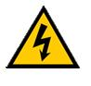
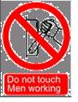
Warning：

(1) Make sure 3phs power cable are completely out of power, should begin detected the components
⑵Welding cable is disconnect from the output terminal
⑶ After a few minute，check input capacitance，3phs rectifier，IGBT components，make sure full discharges should can begin measuring, to prevent electrical shock.
Note matters：
1. Digital Multimeter state diode / resistor / capacitor gear position
2. Using different multimeter for measuring, the value are different.
3. After the digital stable on the multimeter, should can recorded.
4. Make sure the myltimeter’s pen and measurement point in good connector
5. Measurement parts of components need cut off with the control board connector

4.1Conten Prompt：
A: Power transformer T4 measuring
B: Power transformeT5 measuring
C: Power transforme T6 measuring
D: Diverter FL measuring
E: Temperature switch measuring
F: Inductance adjusting potentiometer measuring
G: Closing arc current potentiometer measuring
H: Closing arc voltage potentiometer measuring
I: MMA current potentiometer measuring
J: State switch measuring
K: Torch(standard）switch measuring

4.1 A: power transformerT4 measuring
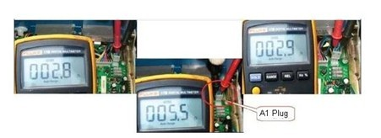
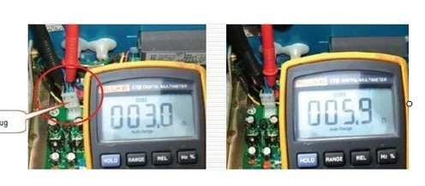
Multimeter range | Red pen-shape meter | Black pen-shape meter | Reference value | remark
Resistance stalls auto range | A1(1) | A1(2) | 2-4Ω | A1(1)—T4(6)  A1(2)—T4(5)  A1(3)—T4(7)
Resistance stalls auto range | A1(1) | A1(3) | 2-4Ω | A1(1)—T4(6)  A1(2)—T4(5)  A1(3)—T4(7)
Resistance stalls auto range | A1(2) | A1(3) | 4-8Ω | A1(1)—T4(6)  A1(2)—T4(5)  A1(3)—T4(7)
Resistance stalls auto range | A10(1) | A10(3) | 2-4Ω | A10(1)—T4(8)  A10(2)—T4(10)  A10(3)—T4(9)
Resistance stalls auto range | A10(2) | A10(3) | 2-4Ω | A10(1)—T4(8)  A10(2)—T4(10)  A10(3)—T4(9)
Resistance stalls auto range | A10(1) | A10(2) | 4-8Ω | A10(1)—T4(8)  A10(2)—T4(10)  A10(3)—T4(9)
Resistance stalls auto range | T4(3) | T4(4) | 2.5-4Ω | Meter supply source

Notes：before measuring, take off MIG control board（KZ1）A1 and A10plug

B: Power transformer T5 measuring
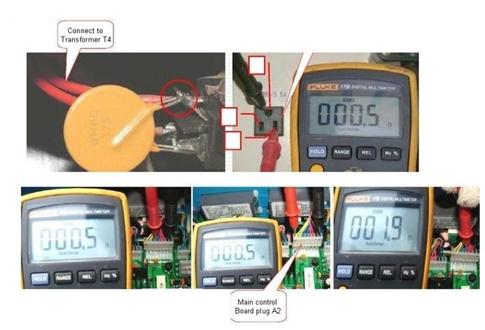
Multimeter range | Red pen-shape meter | Black pen-shape meter | Reference value | remark
Resistance stalls auto range | A2(3) | A2(4) | 2-4Ω | A2(3)—T5(9)  A2(4)—T5(10)
Resistance stalls auto range | A2(1) | A2(5) | 0.2-0.5Ω | A2(1)—T5(7)  A2(5)—T5(6)  A2(7)—T5(8)
Resistance stalls auto range | A2(1) | A2(7) | 0.2-0.5Ω | A2(1)—T5(7)  A2(5)—T5(6)  A2(7)—T5(8)
Resistance stalls auto range | T5(4) | T5(5) | 0.2-0.5Ω | Heating power source
Notes：Before measuring，please take off the plug of MIG main control board （KZ1）
C: Power transformer T6 measuring
Multimeter range | Red pen-shape meter | Black pen-shape meter | Reference value | remark
Resistance stalls auto range | A6(5) | A6(6) | 4-6Ω | A6(5)—T6(5)  A6(6)—T6(6)
Resistance stalls auto range | A2(2) | A2(3) | 2-3Ω | A2(2)—T6(13)  A2(3)—T6(14)
Resistance stalls auto range | A2(4) | A2(6) | 2-3Ω | A2(4)—T6(10)  A2(5)—T6(12)  A2(6)—T6(11)
Resistance stalls auto range | A2(5) | A2(6) | 2-3Ω | A2(4)—T6(10)  A2(5)—T6(12)  A2(6)—T6(11)
Notes：Before measuring，please take off the plug of MMA main control board （KZ2）A2,A6
D: Diverter FL measuring
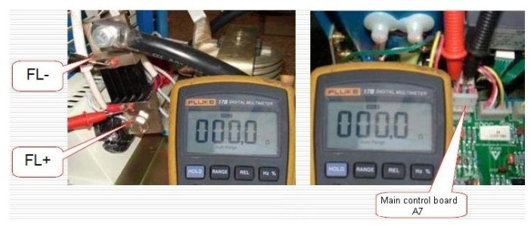
Multimeter range | Red pen-shape meter | Black pen-shape meter | Reference value | remark
Resistance stalls auto range | FL+ | FL- | ＜0.5Ω | A7(4)—FL+
Resistance stalls auto range | A7(4) | A7(3) | ＜0.5Ω | A7(3)—FL-
Notes：Before measuring, please take off the plug of MIG main control board（KZ1）A7

E: Temperature switch measuring
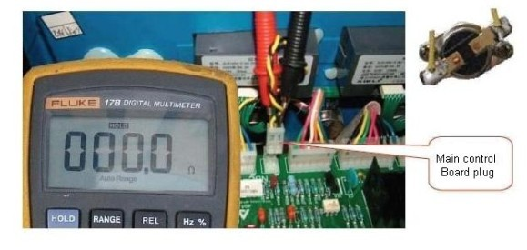

Multimeter range | Red pen-shape meter | Black pen-shape meter | Reference value | remark
Resistance stalls auto range | A5(1) | A5(2) | ＜1 Ω | MIG control board（KZ1）
Resistance stalls auto range | A4(1) | A4(2) | ＜1 Ω | MMA control board（KZ2）
Notes：Before measuring，please take off the plug of main control boar（KZ1）A5,and MMA main control board（KZ2）A4

F: Inductance adjusting potentiometer measuring
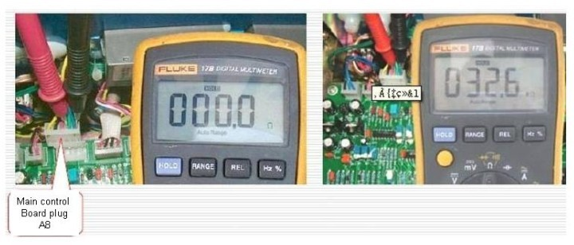
Multimeter range | Red pen-shape meter | Black pen-shape meter | Reference value | remark
Resistance stalls auto range | A8(1) | A8(2) | 5Ω—33K | Adjusting L potentiometer，Resistance changes continuously
Notes：Before measuring，please take off the plug of MIG main control（KZ1）A8
G: Collect arc current potentiometer measuring
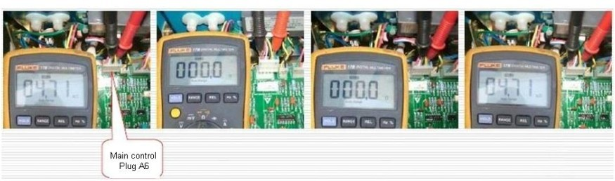

Multimeter range | Red pen-shape meter | Black pen-shape meter | Reference value | remark
Resistance stalls auto range | A6(2) | A6(3) | 5Ω—4.7K | Adjustment potentiometer，Value continue to change
Resistance stalls auto range | A6(2) | A6(5) | 5Ω—4.7K | Adjustment potentiometer，Value continue to change
Notes：Before measuring，please take off MIG main control board （KZ1）A6

H: Collect voltage potentiometer measuring
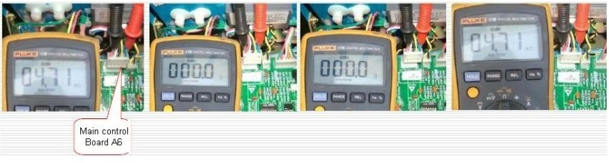
Multimeter range | Red pen-shape meter | Black pen-shape meter | Reference value | remark
Resistance stalls auto range | A6(1) | A6(4) | 5Ω—4.7K | Adjustment potentiometer，Value continue to change
Resistance stalls auto range | A6(1) | A6(5) | 5Ω—4.7K | Adjustment potentiometer，Value continue to change
Notes：Before measuring，please take off the plug of MIG main control board （KZ1）A6

I:MMA current potentiometer measuring
Multimeter range | Red pen-shape meter | Black pen-shape meter | Reference value | remark
Resistance stalls auto range | A1(2) | A1(5) | 5Ω—4.7K | Adjustment potentiometer，Value continue to change
Resistance stalls auto range | A1(2) | A1(6) | 5Ω—4.7K | Adjustment potentiometer，Value continue to change
Notes：before measuring，please take off the plug of MMA main control board （KZ2）A1

J: State switch measuring
Multimeter range | Red pen-shape meter | Black pen-shape meter | Reference value | remark
Resistance stalls auto range | A4(3) | A4(4) | 0Ω | 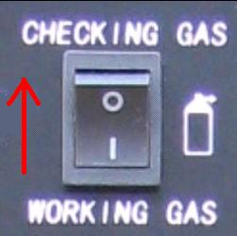
Resistance stalls auto range | A4(3) | A4(4) | 0.L | 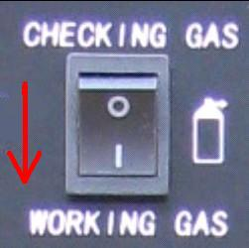
Resistance stalls auto range | A4(6) | A4(3) | 0.L | 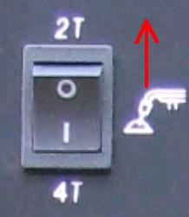
Resistance stalls auto range | A4(6) | A4(3) | 0Ω | 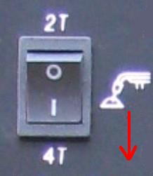
 |  |  | J1，J2 potentiometer close | 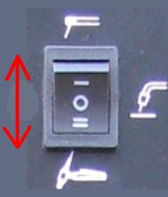
 |  |  | J1，J2potentiometer open | 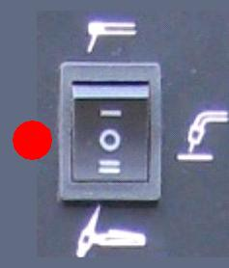
Notes： Before measuring，please take off the plug of MIG main board（KZ1）A4

K: Torch（standard）switch measuring
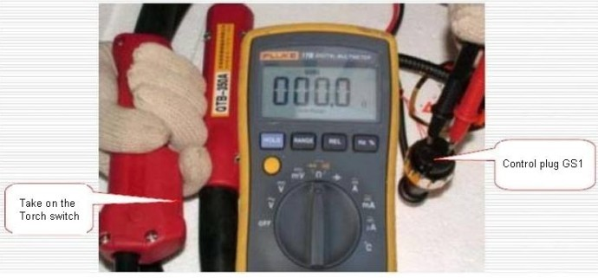
Multimeter range | Red pen-shape meter | Black pen-shape meter | Reference value | remark
Resistance stalls auto range | GS1(1) | GS1(2) | open（＜1Ω） | Press switch
Resistance stalls auto range | GS1(1) | GS1(2) | close（O.L） | Release switch

5 Power on measuring
WARNING：

This measuring only in the air switch not tripped，if air switch has been tripped, it should be detected in the power-off state.
Electric shocks can be fatal：
⑴The inside of the machine high voltage up to 600V, do not touch live parts.

⑵Ensure that physical and work pieces, ground insulation between each other.

⑶Please use a dry, non-destructive, such as insulated gloves to protect. Moving parts can cause injury to human：
⑴Rotating parts (such as fans) will hurt your fingers or loose clothing caught.

⑵When aerial work, use safety nets

Notice：
⑴Digital multimeter state in " AC/DC voltage ".

⑵Measurements on the use of different multimeter,numerical difference.

⑶Digital multimeter stable for record.

⑷Ensure that the multimeter pen-shape metre and detection points connected.

⑸In this manual ,test data is in the power supply voltage of AC380V, if in situ measurements of voltages different from the manual, make sure the supply voltage.

5.1 A:Transformer T4 ---voltage measuring
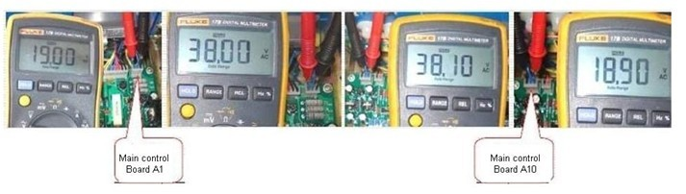
Multimeter measuring range | Red pen-shape metre | Black pen-shape metre | reference value | Remark
AC voltage Automatic  text range | A1(1) | A1(2) | 19V±10% | A1(1)—T4(6)  A1(2)—T4(5)  A1(3)—T4(7)
AC voltage Automatic  text range | A1(1) | A1(3) | 19V±10% | A1(1)—T4(6)  A1(2)—T4(5)  A1(3)—T4(7)
AC voltage Automatic  text range | A10(1) | A10(3) | 19V±10% | A10(1)—T4(8)  A10(2)—T4(10)  A10(3)—T4(9)
AC voltage Automatic  text range | A10(2) | A10(3) | 19V±10% | A10(1)—T4(8)  A10(2)—T4(10)  A10(3)—T4(9)
AC voltage Automatic  text range | T4(3) | T4(4) | 10V±10% | Metet power supply

B:Transformer T5---voltage measuring
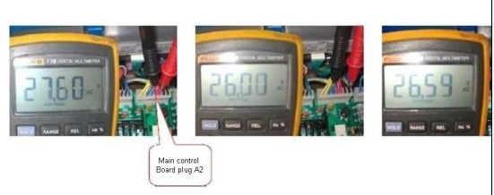
Multimeter measuring range | Red pen-shape metre | Black pen-shape metre | reference value | Remark
AC voltage  Automatic text range | A2(3) | A2(4) | 26V±10% | A2(3)—T5(9)  A2(4)—T5(10)
AC voltage  Automatic text range | A2(1) | A2(5) | 26V±10% | A2(1)—T5(7)  A2(5)—T5(6)  A2(7)—T5(8)
AC voltage  Automatic text range | A2(1) | A2(7) | 26V±10% | A2(1)—T5(7)  A2(5)—T5(6)  A2(7)—T5(8)
AC voltage  Automatic text range | T5(4) | T5(5) | 36V±10% | Heating power
C:Transformer T6 ---voltage measuring

Multimeter measuring range | Red pen-shape metre | Black pen-shape metre | reference value | Remark
AC voltage Automatic  text range | A6(5) | A6(6) | 38V±10% | A6(5)—T6(5)  A6(6)—T6(6)
AC voltage Automatic  text range | A2(2) | A2(3) | 19V±10% | A2(2)—T6(13)  A2(3)—T6(14)
AC voltage Automatic  text range | A2(4) | A2(6) | 19±10% | A2(4)—T6(10)  A2(5)—T6(12)  A2(6)—T6(11)
AC voltage Automatic  text range | A2(5) | A2(6) | 19±10% | A2(4)—T6(10)  A2(5)—T6(12)  A2(6)—T6(11)
D:No-load voltage---measuring

Multimeter measuring range | Red pen-shape metre | Black pen-shape metre | reference value | Remark
DC voltage Automatic  text range | OUTPUT + | OUTPUT_ | 65V±10% | MIG take on torchs witch
DC voltage Automatic  text range | OUTPUT + | OUTPUT_ | 70V±10% | MMA/TIG state
6 Wire feeder measuring
6.1A Single-driven wire feeder
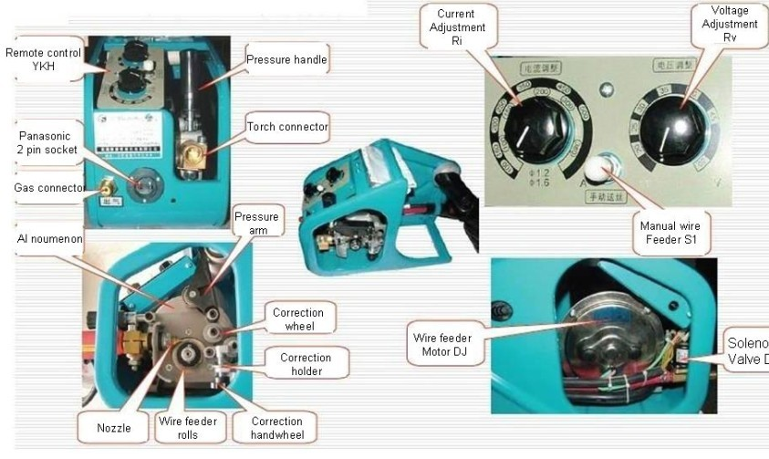

6.1B Euro double-driven wire feeder
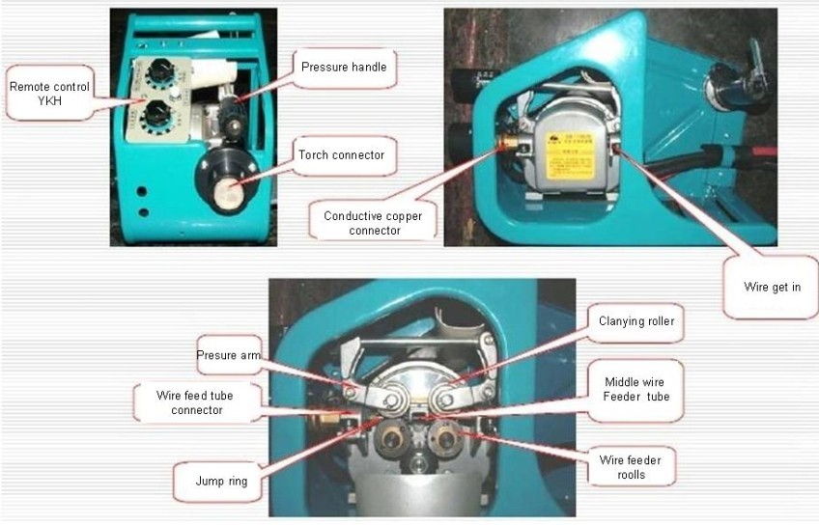

6.1C Remote control wiring diagram
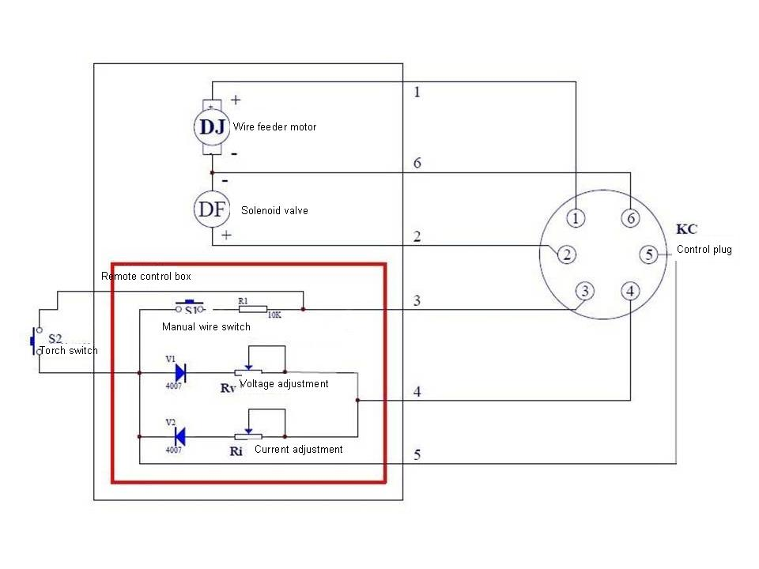
6.2 Power off measuring
warning：

⑴After the three-phase power cable to completely disconnect, you can begin testing components
⑵The welding cable disconnected from the output terminals
⑶Wait a few minutes, measurement input capacitors, three-phase bridge ,IGBT and so on, make sure completely discharge, to prevent electric shock.
Notice：
⑴Digital multimeter state in " Diode/Resistance ".

⑵Measurements on the use of different multimeter,numerical difference.

⑶Digital multimeter stable for record.

⑷Ensure that the multimeter pen-shape metre and detection points connected.

(5)Measuring need be disconnected with welding machine, direct measure control cable plug.

6.2.1 Wire feed motor DJ voltage—measuring
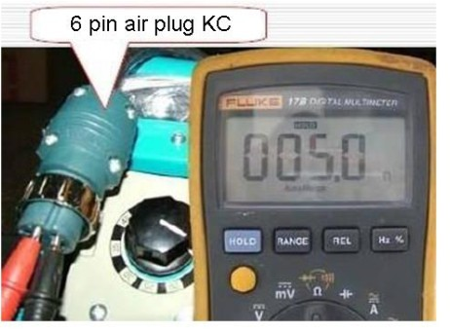
Multimeter measuring range | Red pen-shape metre | Black pen-shape metre | reference value | Remark
Resistance stalls | KC(6) | KC(1) | 4.7—5.5

6.2.2 Solenoid valve DF---measuring
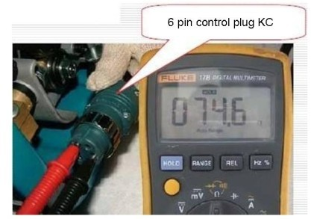
Multimeter measuring range | Red pen-shape metre | Black pen-shape metre | reference value | Remark
Resistance stalls | KC(6) | KC(2) | 50—90

6.2.3 Torch switch、manual wire switch ---maesuring
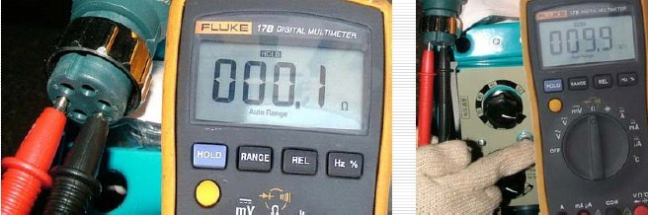

Multimeter measuring range | Red pen-shape metre | Black pen-shape metre | reference value | Remark
Resistance stalls  Automatic range | KC(5) | KC(3) | open（＜1Ω） | Take on torch switch
Resistance stalls  Automatic range | KC(5) | KC(3) | close（O.L） | Take off torch switch
Resistance stalls  Automatic range | KC(3) | KC(5) | 9-11K | Take on manual wire switch
Diode stalls | KC(5) | KC(3) | 0.8V±10% | Take off manual wire switch

    - Given voltagle potentiometer RV---measuring
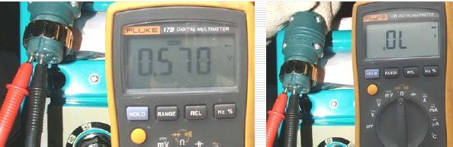

Multimeter measuring range | Red pen-shape metre | Black pen-shape metre | reference value | Remark
Diode stalls | KC(5) | KC(4) | 0.55V—O.L | Potentiometers to djust from small to the largest
Notice：Adjust the potentiometer,the resistance value should continuous change, no jumping
6.2.5 Given current potentiometer RI---measuring
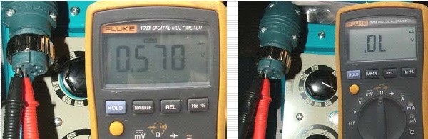

Multimeter measuring range | Red pen-shape metre | Black pen-shape metre | reference value | Remark
Diode stalls | KC(4) | KC(5) | 0.55V—O.L | Potentiometers to adjust from small to the largest

Notice：Adjust the potentiometer,the resistance value should continuous change, no jumping
6.3 Power on measuring
WARNING：

This measuring only in the air switch not tripped，if air switch has been tripped, it should be detected in the power-off state.
Electric shocks can be fatal：
⑴The inside of the machine high voltage up to 600V, do not touch live parts.
⑵Ensure that physical and work pieces, ground insulation between each other.
⑶Please use a dry, non-destructive, such as insulated gloves to protect.

Moving parts can cause injury to human：
⑴Rotating parts (such as fans) will hurt your fingers or loose clothing caught.
⑵When aerial work, use safety nets

Notice：
⑴Digital multimeter state in " AC/DC voltage ".

⑵Measurements on the use of different multimeter,numerical difference.

⑶Digital multimeter stable for record.

⑷Ensure that the multimeter pen-shape metre and detection points connected.

⑸In this manual ,test data is in the power supply voltage of AC380V, if in situ meas
urements of voltages different from the manual, make sure the supply voltage.

6.3.1 Switch singal—measuring
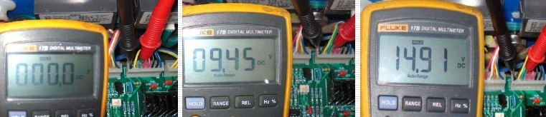

Multimeter measuring range | Red pen-shape metre | Black pen-shape metre | reference value | Remark
AC voltage Automatic text range | A3(6) | A3(8) | 0V | Take on switch for torch
AC voltage Automatic text range | A3(6) | A3(8) | 9V±10% | Press the manual wire feed switch
AC voltage Automatic text range | A3(6) | A3(8) | 14V±10% | Normal not operation

Notice：MIG control board（KZ1）
6.3.2 Solenoid valve DF—measuring
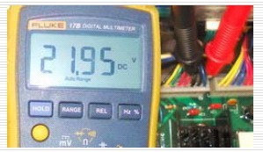

Multimeter measuring range | Red pen-shape metre | Black pen-shape metre | reference value | Remark
AC voltage Automatic text range | A3(1) | A3(3) | 24V±10% | Take on switch for torch
AC voltage Automatic text range | A3(1) | A3(3) | 0V | Take off switch for torch

Notice：MIG control board（KZ1）
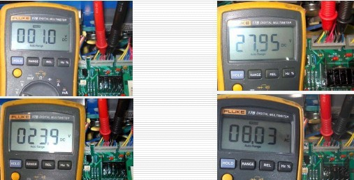
6.3.3 Wire feed motor DJ voltage—measuring

Multimeter measuring range | Red pen-shape metre | Black pen-shape metre | reference value | Remark
AC voltage Automatic text range | A3(2/3) | A3(4/5) | 1-24V±10% | Welding condition（Adjustable current）
AC voltage Automatic text range | A3(2/3) | A3(4/5) | 28V±10% | Manual wire feeding condition
AC voltage Automatic text range | A3(2/3) | A3(4/5) | 1-8V±10% | Slow wire feed（Adjustable current）
Notice：MIG control board（KZ1）

6.3.4 Given signal—measuring
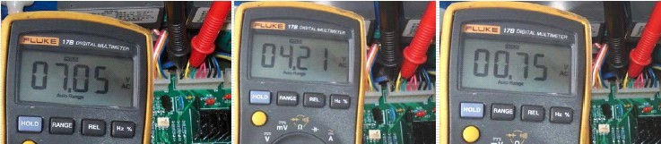

Multimeter measuring range | Red pen-shape metre | Black pen-shape metre | reference value | Remark
AC voltage Automatic text range | A3(7) | A3(8) | 7VAC±10% | Max current ,Max voltage
AC voltage Automatic text range | A3(7) | A3(8) | 4.2VAC±10% | Min current ,Max voltage
AC voltage Automatic text range | A3(7) | A3(8) | 0.7VAC±10% | Min current ,Min voltage
Notice：MIG control board（KZ1）

7 MIG torch
7.1 Panasonic MIG torch
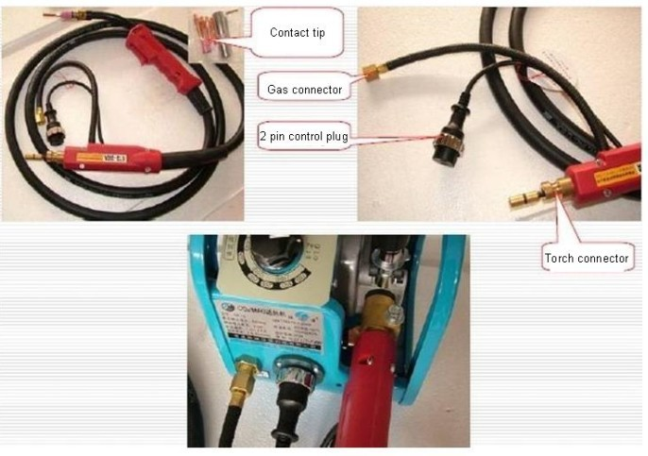

7.2 Euro MIG torch
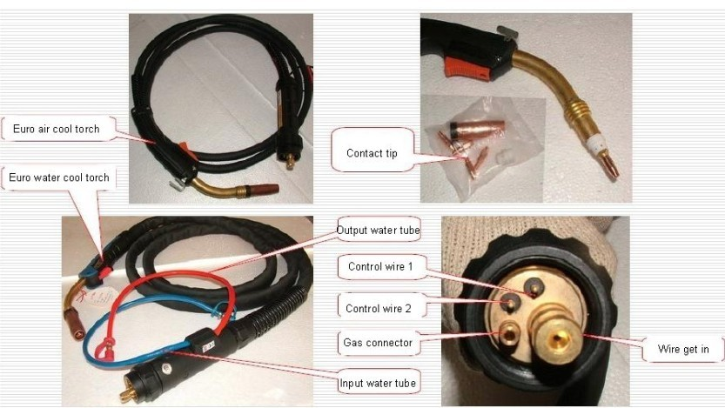

7.3 Wire feed tube
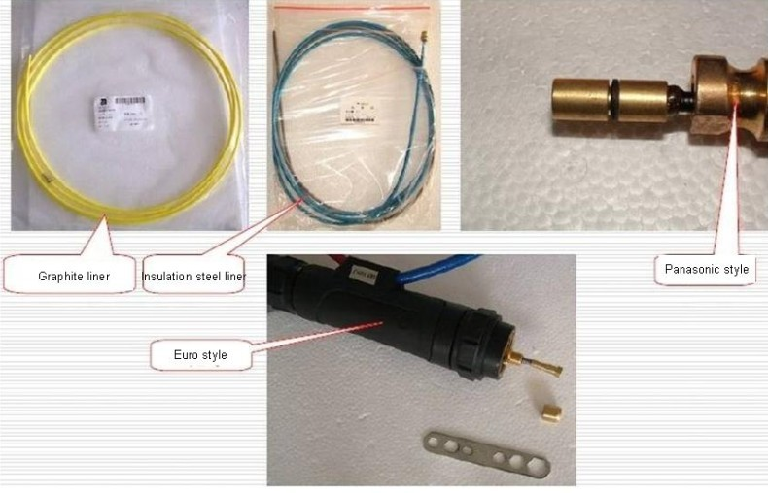

8 Repair and maintenance
WARNING：

1：Welding machines require professional maintenance
2：The inside of the machine high voltage up to 600V, do not touch live parts; Detect the components in machine,it should completely turn off the power. After take off the power, wait a few minutes, measuring the voltagle on DC bus capacitor ,make sure replacement the components after it completely discharge.
3：IGBT is sensitive to static electricity, static electricity will damage module during the operation process。
4：High power module, screw should be uniform.

8.1 Repair and maintenance
1：Every 3-6 months, professionals people use compressed air to dust removal of welding power source, as well as check the fasteners don’tloosein machine. Every 1 month in bad environment.
2：Three-phase power supply voltages are within 340V-420V, make sure missing phase.
3：Make sure reliable earthing and insulation.
4：Often check cable breakage, disconnection, adjustment knob is loose.
5：Check the cable connection to the welding machine terminals for fastening and reliable, avoid damage to the terminals.
6：Check the contact tip, pressure wire wheel and wire wheel,if it be damaged,it should be replaced, often cleaning wire feed hose, ensure the wire feed flow.
7：Check the welding torch not breakage, disconnection, check gun head, nozzle, gas sieve device is loose, burning.
8：Often check the pipe for damage, whether gas table with frosting, not heating.
9：Keep the welding machine with good ventilation, internal welding machine drying.

