1. AC/DC200P
  - The structure drawing of AC/DC200P:
The structure of AC/DC200P is similar to that of AC/DC315P.

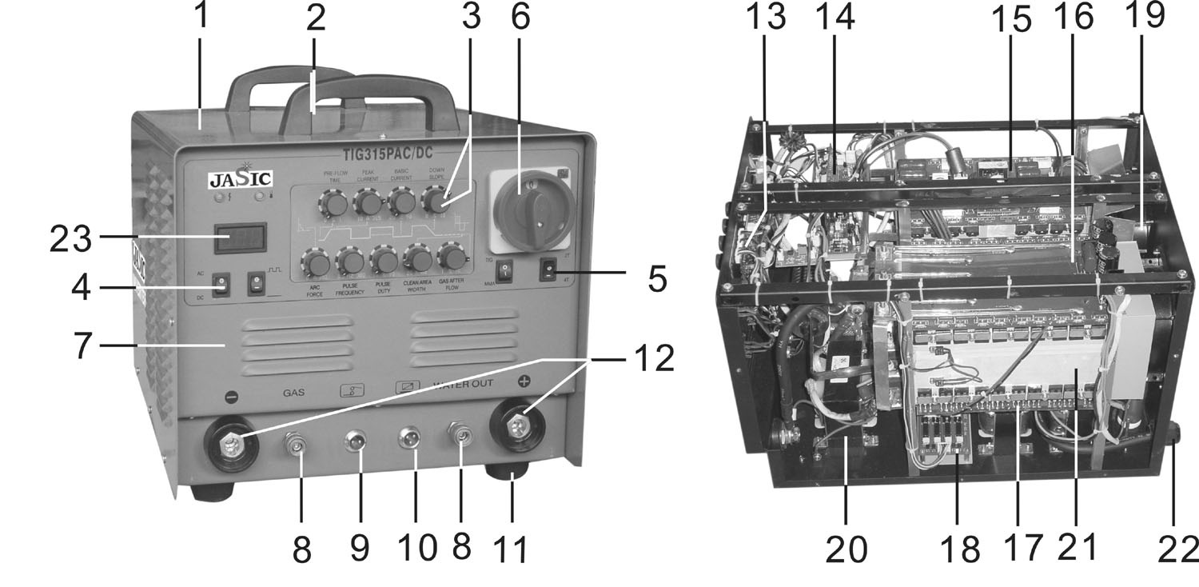
No. | Description | No. | Description | No. | Description
1 | Cover | 9 | Pilot-socket (2 pins) | 17 | Inverter PCB 2
2 | Handle | 10 | Pilot-socket (3 pins) | 18 | AC Driver PCB
3 | Button | 11 | Rubber foot | 19 | Fan
4 | Function switch | 12 | Coupling socket | 20 | Inductance
5 | Function switch | 13 | Panel PCB | 21 | Heat sink
6 | Main switch | 14 | Control PCB | 22 | Input cable
7 | Front panel | 15 | Top PCB (left) | 23 | Digital meter
8 | Fast-socket | 16 | Inverter PCB 1

  - The general connection diagram of AC/DC200P:
1.3 The diagram of AC/DC200P’s top PCB PM-03-A2, center PCB PD-08-B0, bottom PCB PZ-06-B4, control panel PK-31-A0, low-voltage control PCB PK-05-A4, control module PK-03-A1, secondary drive PCB PK-09-A3, secondary inverter PCB PN-07-A1, PN-08-B0, power supply conversion PCB PH-20-A1, meter display preset PCB PH-10-A01:

1.4 Troubleshooting of AC/DC200P:
Trouble | Analysis | Solution
1. Turn on the machine, no display of the meter, the fan doesn’t work, no no-load voltage output in TIG/ARC mode. | - The input voltage is abnormal.  - The power supply cable matching CP3/CP4 on bottom PCB PZ-06-B4 is disconnected, or the tie-in is damaged.  - The power supply switch may be damaged.  - The connecting cable matching socket CON1—CON6 on power supply conversion PCB is in loose connection. | - Check if the input voltage is AC 220V.  - Check.  - Replace the power supply switch if it’s damaged.  - Check.
2. Turn on the machine, the meter displays, press the welding torch switch in TIG mode, there is gas out and no HF, no no-load voltage output in ARC mode. | - The connecting cable matching socket CON1 on bottom PCB PZ-06-A3 is in loose connection.  - The prime relay RELAY3 on bottom PCB PZ-06-A3 doesn’t close well; the value of thermal resistor RT1 increases.  - The connecting cable matching rectifying bridge with socket CON11/CON6 is in loose connection.  - Some part on control module PK-03-A1 is damaged.  - Some part on control PCB PK-05-A4 is damaged. | - Check if the voltage of socket CON1 is DC308V.  - Check and replace if necessary.  - Check.  - Check with a multi-meter if chip U1 is damaged. Check if the 16th pin of U1 is 5V. If it’s not, replace the chip because U1 is damaged. Check if resistor R32, diode D2/D3/D4, zener diode Z1/Z2/Z3, audion Q2/Q3/Q4/Q5/Q6/Q7/Q9, thyristor Q1 or capacitor C17 is damaged.  - Check if MOSFET U2/U3/U4/U5 or resistor R32 is damaged.
3. Turn on the machine, the meter displays, but the thermal resistor RT1/RT2/RT3/RT5 on bottom PCB PZ-06-B4 heats and smokes after a while. | - The connecting cable (+24V) matching socket CON10 on bottom PCB PZ-06-A4 with socket CON14 on control PCB PK-05-A4 is in loose connection.  - The relay RELAY3 on bottom PCB PZ-06-A4 is damaged.  - The auxiliary power supply part on control PCB PK-05-A4 is damaged. | - Check.  - Check.  - Check with a multi-meter if chip U6, audion Q2, MOSFET U1, capacitor C23 or resistor R35 on control PCB PK-05-A4 is damaged.
4. Turn on the machine and it appears normal, there is no-load voltage output in ARC mode, press the welding torch in TIG mode and there is gas out, the malfunction LED is not on, no HF. | - The connecting cable matching socket CON3 on top PCB PM-03-A2 with socket CON3 on bottom PCB PZ-06-B4 is in loose connection.  - High voltage silicon granule D1/D2/D4/D5 or high voltage output capacitor C12/C13 on bottom PCB PZ-06-B4 is damaged.  - The connecting cable is in loose connection with CP1/CP2 on bottom PCB.  - The discharge nozzle P1/P2 on bottom PCB has conglutination, excessive clearance or serious oxidation problem.  - The ARC/TIG conversion switch on the panel or chip U7 on control panel PK-31-A0 is damaged.  - The connecting cable matching socket CON8 on control PCB PK-31-A0 with socket CON2 on bottom PCB PZ-06-B4 is in loose connection, or HF relay RELAY1, audion Q1, MOSFET VT1 or diode D3 on bottom PCB is damaged. | - Check.  - Check.  - Check.  - Adjust or replace it if necessary.  - Check and replace it if necessary.  - Check. Short-circuit socket CON2 on bottom PCB PZ-06-B4, then turn on the machine and press the manual switch. If there is no HF, there is something wrong with the HF circuit on bottom PCB. If there is, the inductor L1/L2, chip U1/U3 or resistor R6 on control PCB PK-31-A0 is damaged.
5. Turn on the machine and it appears normal, press the welding torch switch and there is gas out, the malfunction LED is on, turn to ARC mode, the malfunction LED turns on. | - Over-current protection occurs when welding is carried out.  - Over-heating protection occurs when welding is carried out.  - Some parts on top PCB, center PCB, or bottom PCB are damaged. | - Turn off the machine for 5mins and restart.  - Stop the welding operation for 5mins, or the secondary inverter thermal switch is damaged.  - Check. Turn off the machine, pull out the connecting cable matching the socket CON3 on top PCB PM-03-A2 with the socket CON3 on bottom PCB PZ-06-B4, turn on the machine. If the malfunction LED is off, the transformer T1 is short-circuited or damaged. If it’s on, turn off the machine, pull out the connecting cable matching socket CON1 on top PCB PM-03-A2, turn on the machine. If the malfunction LED is on, MOSFET VT1.1—/VT4.5 on top PCB or some parts on drive module PK-08-A1 are damaged; if it’s off, transformer T2.1/T2.2/  T2.3/T2.4 or rectifying diode D1/D2 on PCB PD-08-B0 is damaged.
6. Turn on the machine and it appears normal, it can start arc in TIG mode, but the welding point appears black. | - The magnet valve or the gas tube is blocked.  - The magnet valve is damaged.  - The connecting cable matching socket CON10 on bottom PCB PZ-06-A4 with socket CON7 on control panel PK-31-A0 is in loose connection.  - Some parts in magnet valve control circuit on bottom PCB PZ-06-B4 or some parts in magnet valve control circuit on control panel PK-31-A0 are damaged.  - The welding torch is damaged.  - The tungsten is of bad quality or the argon is impure. | - Clear.  - Replace.  - Check.  - Check with a multi-meter if the MOSFET VT1, resistor R3/R2, diode D3 or audion Q1 on bottom PCB or audion Q1 on control PCB PK-31-A0 is damaged or if the magnet valve control cable matching the socket CON4 is disconnected.  - Remove the welding torch and the gas-electricity tie-in, and press the welding torch switch. If there is gas out, the welding torch is damaged. Replace it.  - Check and replace it if necessary.
7. The cutting current is unstable and out of control. | - The connecting cable matching socket CON2 on control PCB PK-05-A4 with socket CON11 on control panel PK-31-A0 is in loose connection.  - The capacitor C14/C15/C16/C9/C7/C8 on bottom PCB PZ-06-B4 leaks or is damaged.  - The input cable or output cable is too slim and too long.  - Loose connection exists inside the machine, e.g. the remote control connecting cable matching socket CON4 on control panel. | - Check and replace it if necessary.  - Check and replace it if necessary.  - Enlarge the cross section area of the cable.  - Check.
8. Turn on the machine but it strips. | - The rectifying bridge matching the socket CON6/CON11 on bottom PCB PZ-06-B4 is damaged.  - The power supply cable is disconnected or short-circuited. | - Replace.  - Check.
9. Adjust the decay potentiometer to the max value and release the welding torch switch, the gas shuts off and then no current output. | - The diode D1/D2 or chip U3 on control panel PK-10-A1 is damaged. | - Check and replace it if necessary.
10. Press the welding torch switch, there is HF discharge buzz, but no welding voltage output. | - The earth cable of welding torch is in loose connection.  - The output terminal of the earth cable is in loose connection with gas-electricity tie-in or with center PCB PD-01-A2. | - Check and replace it if necessary.  - Check and replace it if necessary.
11. The arc starting is bad in TIG mode. | - The space between discharge nozzles P1 and P2 on bottom PCB PZ-06-B4 is too big or small, or their surface is badly oxidized.  - The high-voltage capacitor C12/C13 on bottom PCB is damaged, or the capacitance becomes smaller.  - The tungsten is of bad quality or the argon is impure.  - The welding torch is in loose connection.  - Incorrect turn rate or turn-to-turn electricity leakage problem exists in arc-starting coil matching CP1/CP2 on bottom PCB. | - Adjust the space between them, or clear their surface.  - Check and replace it if necessary.  - Check and replace it if necessary.  - Check.  - Check.
12. Turn on the machine, and it appears normal, but the malfunction LED turns on once welding is carried out. | - The connecting cable matching socket CON11 on control PCB PK-05-A4 with the output bypass is in loose connection.  - Loose contact exists in MOSFET VT1.1—VT4.5 on top PCB PM-03-A2 or rectifying diode D1/D2 on center PCB PD-08-B1.  - Some parts on control module PK-03-A1 are damaged. | - Check.  - Check with a multi-meter.  - Check if the chip U2 or audion Q9 on PK-03-A1 is damaged.
13. Turn on the machine, and there is HF. | - Some parts in manual switch control circuit are damaged.  - The connecting cable matching socket CON8 on control panel PK-31-A0 with socket CON2 on bottom PCB PZ-06-B4 is in loose connection, or chip U1 on control panel PK-31-A0 is damaged. | - Check with a multi-meter if chip U8 or diode D14/D18 on control panel PK-31-A0 is damaged. Disconnect the connecting cable matching socket CON9, and short-circuit both terminal of CON9, then check if the manual switch board PH-10-A1 is short-circuited.  - Check.
14. Incessant HF exists when welding is carried out. | - The relay RELY1, audion Q1, diode D3, MOSFET VT1 on bottom PCB PZ-06-B4 or chip U1 on control panel PK-31-A0 is damaged.  - The connecting cable matching socket CON13 on control panel PK-31-A0 with socket CON5 on control PCB PK-05-A4. | - Check and replace it if necessary.  - Check.
15. There is deviation between the preset value and real value of the show value of the meter. | - The value of the variable resistor R9 on control PCB PK-05-A4 or VR1 on preset PCB PH-10-A01 changes. | - Adjust. Methods: 1. Turn to ARC mode, adjust the value of variable resistor R9 on control PCB PK-05-A4 to make the show value of the meter is 200. 2. Turn to TIG mode, do not press the manual switch, adjust the value of variable resistor VR1 on preset PCB to make the show value of the meter is 200.
16. No pulse in the pulse mode. | - The pulse conversion switch on the panel is damaged.  - The connecting cable matching socket CON2/CON3 on control panel PK-31-A0 with the pulse conversion switch is short-circuited, or chip U4, capacitor C4/C11, potentiometer VR2/VR3 or diode D24 is damaged. | - Check and replace it if necessary.  - Check.
17. When no-load in ARC mode, it appears normal in DC mode, but there is abnormal sound in AC mode. | - Some of the MOSFET on the secondary inverter PCB PN-07-A1/PN-08-B0 is damaged. | - Check. Method: Turn to ARC mode, then AC mode, turn off the machine after 3mins of no-load, touch the MOSFET on the secondary inverter PCB with your hand one by one. The extra hot ones are damaged.
18. No 4T state or 4T is inaccurate. | - The 2T/4T conversion switch on the panel is damaged, or the connecting cable matching it with socket CON10 on control panel PK-31-A0 is in loose connection.  - Some part on control panel PK-31-A0 is damaged. | - Check.  - Check if chip U8/U2, diode D6 or capacitor C2 on control panel is damaged.
19. No AC output in AC mode. | - The AC/DC conversion switch on the panel is damaged.  - Some part on the control panel PK-31-A0 is damaged.  - Some part on the secondary drive PCB PK-09-A3 is damaged. | - Check.  - Check if the diode D9/D2/D1, audion Q2, chip U6 or potentiometer VR4 on control panel is damaged.  - Check with a multi-meter if chip U2/U4/U8/U9/U3, audion Q1—Q8 or zener diode Z1/Z2/Z3/Z4 on drive PCB is damaged.
20. No AC sound when welding in AC mode. | - The value of the resistor matching socket CON1 on inverter PCB PN-07-A1 varies.  - The MOSFET VT1, rectifying diode VT11, diode D1 or zener diode Z3 on inverter PCB PN-07-A1 is damaged. | - Check and replace it if necessary.  - Check and replace it if necessary.
21. Press the welding torch switch, there is gas out, the show value of the meter is invariable, there is only small current, and the pre-flow time is variable. | - The connecting cable matching socket CON11 on control panel PK-31-A0 with socket CON2 on control PCB PK-05-A4 is in loose connection.  - Some part on control panel PK-31-A0 is damaged. | - Check.  - Check if chip U5, audion Q3/Q4 or potentiometer VR7 on control panel PK-31-A0 is damaged.
22. When the pulse conversion switch is in no-pulse mode, in ARC or TIG mode, the welding current is invariable, and there is only maximum current. | - The diode D24 on control panel PK-31-A0 is damaged. | - Check.
23. Turn on the machine, the indicator of protection status is on because the voltage is too low. | - The input voltage is too low or is unstable.  - The thermal switch matching socket CON14 on control panel PK-31-A0 is damaged.  - The connecting cable matching socket CON15 on control panel PK-31-A0 is in loose connection.  - The resistor R51/R44 or chip U6 on control panel PK-31-A0 is damaged. | - Check.  - Check.  - Check.  - Check. Method: properly reduce the value of resistor R44.

