C.50Hz,230V Without Parallel Receptacle
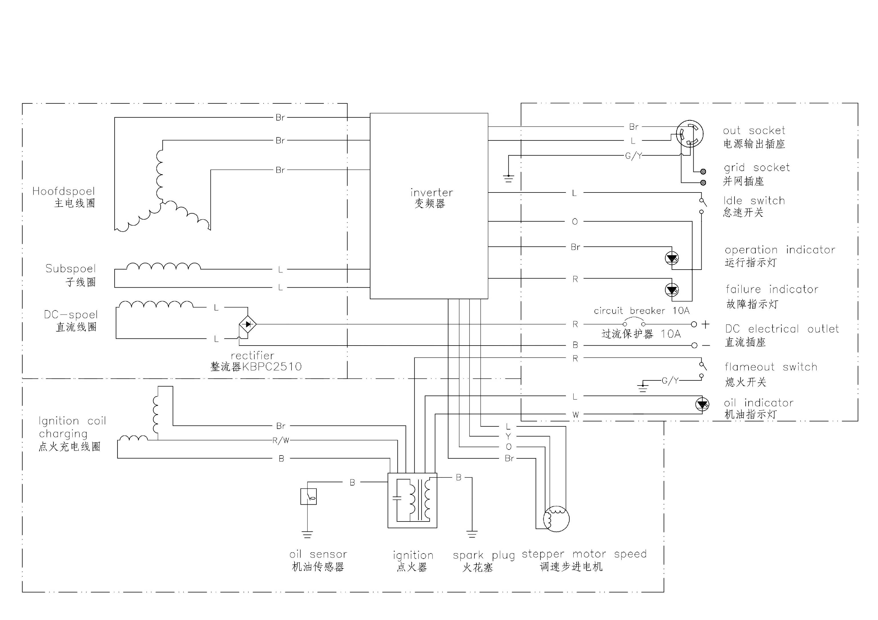
50Hz,230V

D.50Hz,230V With Parallel Receptacle
50Hz,230V

