OPERATOR’S MANUAL

AIR PLASMA CUTTER

CUT60





2009-06
content
§1 SAFETY 1
§2 Technology Parameters 4
2.1 Working principle of main circuit 4
2.2 Parameters 4
2.3 Features: 5
§3 Installation 6
3. 1 Unpacking 6
3.2 Input Power Connections 6
3. 3 Gas Connections 6
§4 Operation 7
4.1 Layout Of The Front And Rear Panel 7
4.2 Cutting Preparation 8
4.3 Cutting Operation 9
§5 Maintenance 11
5.1 Basic Troubleshooting Guide 11
5.1.1 Basic troubles 11
5.1.2 Pilot arc troubles 12
5.1.3 Cutting troubles 12
§6 Cutting Capability 14
6.1 Carbon steel 14
6.1.1 Optimal 14
6.1.2 Quality 14
6.1.3 Supreme 14
6.2 Other materials 15
Appendix 1: Electrical principle drawing 16
Appendix 2: Torch parts schematic drawing 17

§1 SAFETY

Important Safety Precautions

OPERATION AND MAINTENANCE OF PLASMA ARC EQUIPMENT CAN BE DANGEROUS TO YOUR HEALTH.
- Plasma arc cutting produces intense electric and magnetic emissions that may interfere with the proper function of cardiac pacemakers, hearing aids, or other electronic health equipment. Persons who work near plasma arc cutting applications should consult their medical health qualified technician and the manufacturer of the health equipment to deter- mine whether a hazard exists.
- To prevent possible injury, read, understand and follow all warnings, safety precautions and instructions before using the equipment.

GASES AND FUMES


Gases and fumes produced during the plasma cutting process can be dangerous and hazardous to your health.
- Keep all fumes and gases from the breathing area. Keep your head out of the cutting fume plume.
- Use an air-supplied respirator if ventilation is not adequate to remove all fumes and gases.
- The kinds of fumes and gases from the plasma arc depend on the kind of metal being used, coatings on the metal, and the different processes. You must be very careful when cutting or cutting any metals which may contain one or more of the following:

Antimony | Chromium | Mercury | Beryllium
Arsenic | Cobalt | Nickel | Lead
Barium | Copper | Selenium | Silver
Cadmium | Manganese | Vanadium

Always read the Material Safety Data Sheets (MSDS) that should be supplied with the material you are using.
These MSDSs will give you the information regarding the kind and amount of fumes and gases that may be
dangerous to your health.
- Use special equipment, such as water or down draft cutting tables, to capture fumes and gases.
- Do not use the plasma torch in an area where combustible or explosive gases or materials are located.
- Phosgene, a toxic gas, is generated from the vapors of chlorinated solvents and cleansers. Remove all sources of these vapors.

ELECTRIC SHOCK

Electric Shock can injure or kill. The plasma arc process uses and produces high voltage electrical energy. This electric energy can cause severe or fatal shock to the operator or others in the workplace.
- Never touch any parts that are electrically “live” or “hot.”
- Wear dry gloves and clothing. Insulate yourself from the work piece or other parts of the cutting circuit.
- Repair or replace all worn or damaged parts.
- Extra care must be taken when the workplace is moist or damp.
- Disconnect power source before performing any service or repairs.
- Read and follow all the instructions in the Operating Manual.

FIRE AND EXPLOSION

Fire and explosion can be caused by hot slag, sparks, or the plasma arc.
- Be sure there is no combustible or flammable material in the workplace. Any material that cannot be removed must be protected.
- Ventilate all flammable or explosive vapors from the workplace.
- Do not cut or weld on containers that may have held combustibles.
- Provide a fire watch when working in an area where fire hazards may exist.
- Hydrogen gas may be formed and trapped under aluminum workpieces when they are cut underwater or while using a water table. DO NOT cut aluminum alloys underwater or on a water table unless the hydrogen gas can be eliminated or dissipated. Trapped hydrogen gas that is ignited will cause an explosion.

NOISE
Noise can cause permanent hearing loss. Plasma arc processes can cause noise levels to exceed safe limits. You must protect your ears from loud noise to prevent permanent loss of hearing.
- To protect your hearing from loud noise, wear protective ear plugs and/or ear muffs. Protect others in the workplace.
- Noise levels should be measured to be sure the decibels (sound) do not exceed safe levels.

PLASMA ARC RAYS

Plasma Arc Rays can injure your eyes and burn your skin. The plasma arc process produces very bright ultra violet and infra red light. These arc rays will damage your eyes and burn your skin if you are not properly protected.

- To protect your eyes, always wear a cutting helmet or shield. Also always wear safety glasses with side shields, goggles or other protective eye wear.
- Wear cutting gloves and suitable clothing to protect your skin from the arc rays and sparks.
- Keep helmet and safety glasses in good condition. Replace lenses when cracked, chipped or dirty.
- Protect others in the work area from the arc rays. Use protective booths, screens or shields.

§2 Technology Parameters

2.1 Working principle of main circuit
The working principle of LG-60 Air Plasma Cutting Machine is shown as the following figure. Three-phase 380V work frequency AC is rectified into DC (about 530V), then it is converted to medium frequency AC (about 20 KHz) by inverter device (discrete IGBT), after reducing voltage by medium transformer (the main transformer) and rectified by medium frequency rectifier (fast recovery diode), and is outputted by inductance filtering. The circuit adopts current feedback control technology to insure current output stably. Meanwhile, the cutting current parameter can be adjusted continuously and steplessly to meet with the requirements of cutting craft.
图2.1 Working principle diagram

2.2 Parameters
Table2.1 Technical parameters
Models  Parameters |  | CUT60
Rated input voltage（V） |  | 3-380V±15%，50/60Hz
Rated input current（A） |  | 15
Rated input power（KW） |  | 6.75
Cutting current adjustment range （A） |  | 20～60
Pilot current（A） |  | 20
No-load voltage (V) |  | 315
Duty cycle（40℃ 10minutes） |  | 60%(60A) | 100%(46A)
The max. cutting thickness to Carbon steel（mm） |  | 35 | 28
Optimal cutting thickness (mm) | Carbon steel | ≤ 25 | ≤ 20
Optimal cutting thickness (mm) | Stainless steel | ≤ 25 | ≤ 20
Optimal cutting thickness (mm) | Aluminium | ≤ 20 | ≤ 15
Optimal cutting thickness (mm) | Cuprum | ≤ 14 | ≤ 10
Dimensions（mm） |  | 520*240*400
Protection class |  | IP23S
Insulation class |  | F
Net weight (kg)） |  | 24
Cooling method |  | FAN
Note: The above parameters are subject to change with the improvement of machines.

2.3 Features:
- IGBT parallel balanced current technology and digital control technology.
- Wider input voltage flexibility provides peak performance power under variable conditions (±15%) for steady cuts.
- EMI filter restrains the EMI transmission of the power.
- Starts without high-frequency so it will not interfere with controls or computers.
- Pilot Arc Controller increases cutting capabilities and speeds, and improves tip life. So it can be applied to cut netlike workpiece.
- Various protective and alarm functions for pressure, tip, over-temperature and over-current allow faster troubleshooting, eliminating unnecessary downtime.
- Back striking tip and electrode ensure the velocity of striking and the quality of arc, and extend the life of them.

§3 Installation

3. 1 Unpacking
Use the packing lists to identify and account for each item.
- Inspect each item for possible shipping damage. If damage is evident, contact your distributor and / or shipping company before proceeding with the installation.
- When using forklift, its arm length must be long enough to reach the outside so as to ensure lifting safely.
- The movement may bring the potential danger or substantive hazard, so please make sure that the machine is on the safe position before using.

3.2 Input Power Connections
Supply input connection of LG-60 power is shown as the Fig3.1.
- Check your power source for correct voltage before plugging in or connecting the unit
- Power Cord and Plug This power supply includes an input power cord and plug suitable for 380V AC 3 - Phase input power.
- If the power supply voltage continually goes beyond the range of safe work voltage range, it will shorten the welder life-span. The following measures can be used:
- Change the power supply input. Such as, connect the welder with the stable power supply voltage of distributor;
- Reduce the machines using power supply in the same time;
- Set the voltage stabilization device in the front of power cable input.

3. 3 Gas Connections
Fig 3.1 the connect method of the main supply

- Connecting Gas Supply to Unit
Connect the gas line to the inlet port of the gas filter on the rear panel.
- Check Air Quality
To test the quality of air, put the RUN / SET switch in the SET (down) position, check if there are Any oil or moisture in the air.

§4 Operation

4.1 Layout Of The Front And Rear Panel

Fig 4.1 schematic drawing of the front panel and rear panel

- Power pilot lamp
- Over-current , over-heat alarm when over-heat, over-current, the lamp would be on.
- Cutting gun improper installation and air pressure low alarm
- Work lamp turn on the switch of the cutting gun, generate the voltage, the lamp on
- Cutting current regulator it is used to regulate the current when cutting.
- 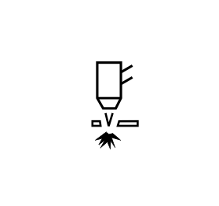 Normal Cut
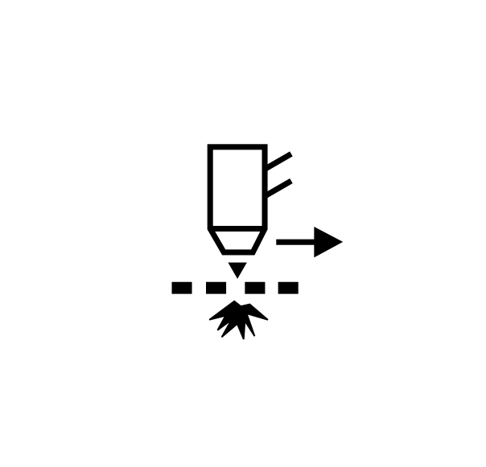 Grid Cut
Note: When these two functions toggling, check gas for 10 seconds and then stop it. During this process, press and release the gun switch quickly, gas check finishes.
- Positive output cable connected to the workpiece
- Cutting gun connector connected to the cutting machine
- Barometer ensure there are no impurity and moisture in the compressed air
- Compressed air output connector
- Power switch turn on or off the power source
- Power cable connected to the appreciate power supply

4.2 Cutting Preparation
- Tightly connect the power cable to electrical socket outlet (the input voltage, refer to the section 2 technology parameters)
- Tonnect the air pipe to the air supply equipment, the earth cable to the workpiece
- Turn on the power switch ,the power source lamp on.
- Turn the RUN/SET switch to SET position, the air flow, then regulate the air pressure to 3.5-6bar
- Turn the RUN/SET switch to RUN position, regulate the current after the flow stops.
- Now all the preparation done .

4.3 Cutting Operation
1. Normal Cut
Turn on the power source
Automatic gas test for 10S
Loose the cutting torch trigge.
Pre-gas for 2s
The torch move away the workpiece, then , the arc stops

Automatic examine for 5s
After Initialization and the fan stop, press on the torch trigger

Ignite the pilot arc, the max. time is10s
Post-gas
If the tip touch the workpiece and the current higher than 40A, isn’t it ?
Shift to the workpiece, the pilot arc change into cutting arc
Yes
No
The current will down to 40A
Cutting
Is the torch trigger pressed on again among the period of post-gas ?

Yes
No
Restart and continue working
Finish after post-gas for 15s

Fig 4.2 the working flow chart

2. Grid Cut
Turn on the power source
Automatic gas test for 10S
Loose the cutting torch trigger, the arc stops
Pre-gas for 2s
The torch move away the workpiece, then the cutting arc change into the pilot arc
Automatic examine for 5s
After Initialization and the fan stop, press on the torch trigger

Ignite the pilot arc, the max. time is10s
Post-gas
If the tip touch the workpiece and the current higher than 40A, isn’t it ?
Shift to the workpiece, the pilot arc change into cutting arc
Yes
No
The current will down to 40A
Cutting
Is the torch trigger pressed on again among the period of post-gas ?

Yes
No
Restart and continue working
Finish after post-gas for 15s

Fig 4.3 the working flow chart

Note:
- The alarm lamp on when cutting, it is needed to loose the switch of the torch until the alarm release, then press on the switch to restart working.
- In the automatic gas test and examine, press on the cutting torch, there will no reflection.
- After a long usage, the surface of the electrode and nozzle will have Oxidation reaction. Please replace the electrode and nozzle, For The alarm lamp will on when install the shield cup, and stop working
- It is forbidden to take down the fittings of the cutting torch when the trigger is pressed.
- If the cutting current is higher than 40A, when the tip touch the workpiece, the current will down to 40A in oder to protect the tip.
- Among the period of post gas, if you press the trigger for a long time, the arc restars; if you press and loosen the trigger quickly, the gas stops, after it you can press the trigger for a long time to restart the machine as well.
Account for the alarm indicator:
- When the machine appears over-heat or over-current , the yellow indicator (lamp 2) on the front panel will on continually.
  - Over-heat: The alarm will release after the period of fan cooling. You can restart the machine.
  - Over-current: The alarm is beyond retrieve. You must ask the qualified technician to check the machine.
- When any of the torch parts (include Tip, electrode, shield cup and gas distributor) isn’t installed, the red indicator (lamp 3) glitters.
- When the air pressure is too lower, the indicator (lamp 3) will on continually.
- When the gas distributor is un-installed only, there is not alarm while operating the machine, and when you press the trigger, there is no arc and no load as well. Open the torch and check it.

§5 Maintenance

5.1 Basic Troubleshooting Guide

WARNING

There are extremely dangerous voltage and power levels present inside this unit. Do not attempt to diagnose or repair unless you have had training in power electronics measurement and troubleshooting techniques.

5.1.1 Basic troubles
- Turn on the machine, the power indicator lights up, but both of the fan and the air control valve is no action.
- Absent Phases. Please check the input lines, and connect it correctly.
- The main board in the machine is break. Please ask the qualified technician to change it.
- Turn on the machine, the TIP/GUN/GAS indicator lights up.
- Gas pressure is too low. Adjust the gas pressure to 65psi/4.5bar. The Barometer indicate to 0.45~0.5MPa.
- Turn on the machine, the TIP/GUN/GAS indicator glitter.
- The shield cup is unfitted installation, Turn off the power source, install and screw it properly, then turn on the power source.
- The Tip or electrode is unfitted installation, Turn off the power source, and install and screw shield cup properly, then turn on the power source.
- The temperature indicator lights up after the machine working a few of minutes.
- Air flow blocked, check for blocked air flow around the unit and correct condition.
- Fan blocked, check and correct condition.
- The machine is over-heat, let it cool down for at least 5 minutes. Make sure the machine has not been operated beyond the Duty Cycle (refer to technology parameters in Section 2).
- Input voltage over the normal range, choosing the proper voltage (refer to technology parameters in the Section).
- Faulty components in the machine, return for repair or have qualified technician repair per Service Manual.

5.1.2 Pilot arc troubles
- Torch failed to ignite the arc when torch is triggered.
- The system is set in “SET” mode, change it to “RUN” mode.
- Faulty in torch parts, inspect torch parts and replace it if necessary.
- Gas pressure is too high or too low, adjust it to proper state.
- Faulty components in the machine, return for repair or have qualified technician repair per Service Manual.
- Difficult igniting
- The gas distributor is un-installed
- Worn torch parts (consumables), shut off input power. Remove and inspect torch shield cup, tip, starter cartridge, and electrode. Replace electrode or tip if worn; replace starter cartridge if end piece does not move freely; replace shield cup if excessive spatter adheres to it.
- The machine is in trouble. Please ask the qualified technician to check it and repair the machine.
- The torch is triggered, but the pilot arc isn’t change to the cutting pilot. The power indicator lights up; Gas flows; Fan operates.
- It is inaccurate connection between torch and power supply, check the torch leads are properly connect to power supply.
- Work cable not connected to work piece, or connection is poor, make sure that work cable has a proper connection to a clean and dry area of the workpiece.
- Faulty components in the machine, return for repair or have qualified technician repair per Service Manual.
- Faulty Torch, return for repair or have qualified technician repair it.
- Arc shuts off during operation, and it will not restart when torch is triggered.
- Power Supply is overheated (OC/OT lamp on), let unit cool down for at least 5 minutes. Make sure the unit has not been operated beyond Duty Cycle limit. Refer to Section 2 for duty cycle specifications.
- Gas pressure too low (the TIP/GUN/GAS lamp on when press on torch switch is on), check source for at least 65 psi / 4.5 bar; adjust as needed.
- Torch consumables worn, check torch shield cup, tip, starter element, and electrode; replace as needed.
- Faulty components in unit:, return for repair or have qualified technician repair per Service Manual.

5.1.3 Cutting troubles
- No gas flow; the power lamp on; Fan operates
- Gas pipe not connected or pressure is too low, check gas connections. Adjust gas pressure to proper setting.
- Faulty components in the unit, return for repair or have qualified technician repair.
- Low cutting output
- Incorrect setting of cutting current (A), check and adjust to proper setting.
- Faulty components in unit, return for repair or have qualified technician repair.
- Torch can cut but the cutting quality is poor
- Current (A) control set too low, increase current setting.
- The torch move too fast across the workpiece, reduce cutting speed.
- Excessive oil or moisture in torch, hold torch 1/8 inch (3 mm) from clean surface while purging and observe oil or moisture buildup (do not activate torch). If there are contaminants in the gas, additional filtering may be needed.
- Lack of air pressure. Please check the air pressure and air flow, adjust it to the appropriate position

§6 Cutting Capability

6.1 Carbon steel

6.1.1 Optimal
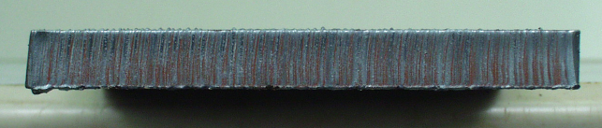
Thickness: 10mm
Approximate Travel Speeds: (293mm/min, 60A)
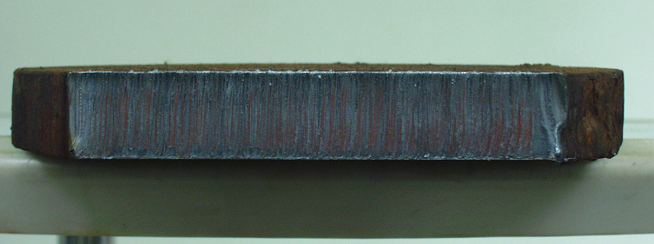
Thickness: 18mm
Approximate Travel Speeds: (200mm/min, 60A)

6.1.2 Quality
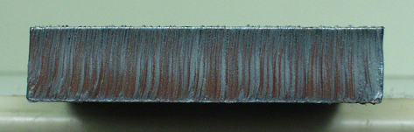
Thickness: 20mm
Approximate Travel Speeds: (160mm/min, 60A)

6.1.3 Supreme
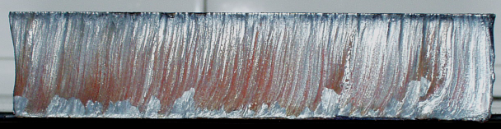
Thickness: 35mm
Approximate Travel Speeds: (78mm/min, 60A)

6.2 Other materials
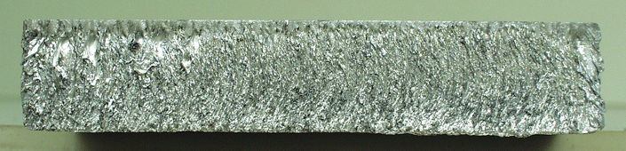
Al
Thickness: 20mm
Approximate Travel Speeds: (197mm/min, 60A)

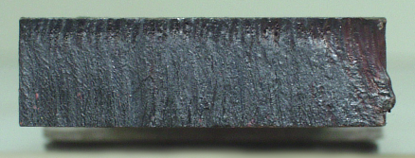
Cu
Thickness: 10mm
Approximate Travel Speeds: (168mm/min, 60A)

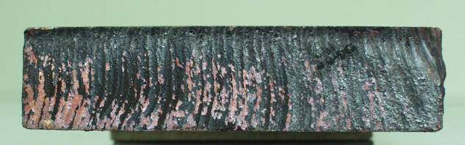
Cu
Thickness: 14mm
Approximate Travel Speeds: (196mm/min, 60A)

Appendix 1: Electrical principle drawing

Appendix 2: Torch parts and connection schematic drawing
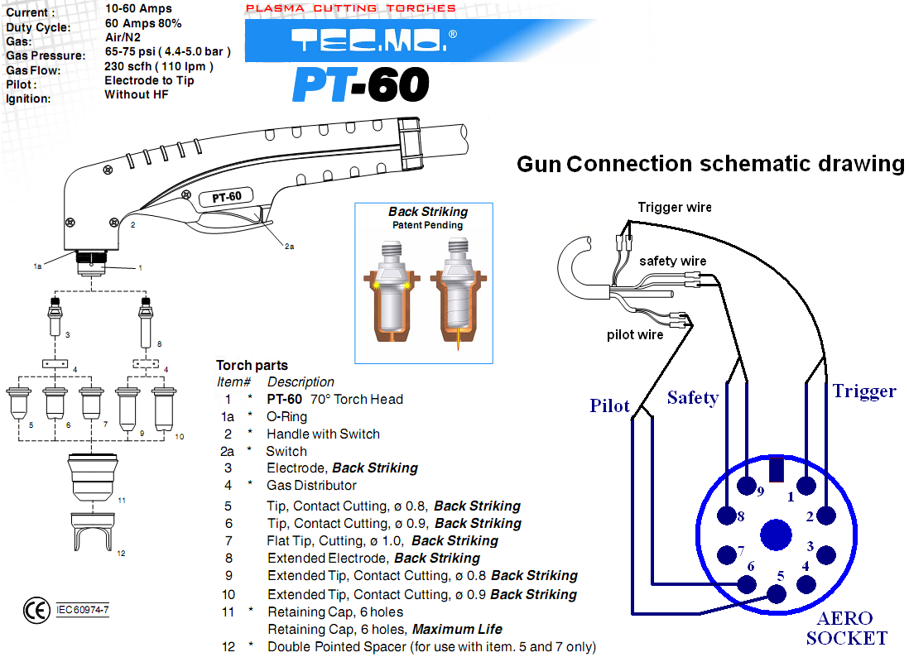

NOTE:

- Please give a good screw to the electrode while installing, but do not excessively.
- Please install the torch parts completely, otherwise the machine will alarm after turning on.

